

**Tribhuvan University**

**Institution of Science and Technology**

**A Final Year Project Report On**

**EMERGENCY RESPONSE SYSTEM USING DIJKSTRA’S ALOGORITHM IN THE CONTEXT OF THE KATHMANDU VALLEY**

**Under the Supervision of**

**Er. Nipun Thapa**

**Lecturer**

**Orchid International College**

**Submitted To:**

**DEPARTMENT OF COMPUTER SCIENCE AND INFORMATION TECHNOLOGY**

**ORCHID INTERNATIONAL COLLEGE**

**In partial fulfillment for the Bachelor’s Degree in Computer Science and Information Technology**

**Submitted By:**

**Ankit Shrestha (23863/076)**

**Anusha Giri (23865/076)**

**Ritika Joshi (23883/076)**

**March 2024**



# **SUPERVISOR’S RECOMMENDATION**

I hereby approve the report made under my supervision by Ankit Shrestha (TU  
Exam Roll No. 23863/076), Anusha Giri (TU Exam Roll No. 23865/076), Ritika Joshi.  
(TU Exam Roll No. 23883/076) entitled "**EMERGENCY RESPONSE SYSTEM USING DIJKSTRA'S ALGORITHM IN THE CONTEXT OF THE KATHMANDU VALLEY**" will be evaluated as part of the requirements for the degree of B.Sc. in Computer Science and Information Technology.

…………………………

**Er. Nipun Thapa**

Full Time Faculty

Orchid International College

Bijyachowk, Gaushala



# **CERTIFICATE OF APPROVAL**

This certifies that the project "**EMERGENCY RESPONSE SYSTEM USING DIJKSTRA'S ALGORITHM IN THE CONTEXT OF THE KATHMANDU VALLEY**," completed by Ankit Shrestha (TU Exam Roll No. 23863/076), Anusha Giri (TU Exam Roll No. 23865/076), and Ritika Joshi (TU Exam Roll No. 23883/076), partially fulfills the requirements for the degree of B. Sc. in Computer Science and Information Technology. We believe it to be a suitable project for the desired degree in terms of both scope and quality.

|  |  |
| --- | --- |
| ……………………..  **Er. Nipun Thapa**  Supervisor,  Orchid Interna6onal College  Bijyachowk, Gaushala | …………………………  **Er. Dhiraj Kumar Jha**  Program Coordinator,  Orchid Interna6onal College  Bijyachowk, Gaushala |
| ……………………….  **Shikha Sharma**  Internal Examiner,  Orchid Interna6onal College  Bijyachowk, Gaushala | ……………………  **External Examiner**  Central Department of Computer Science and IT, Tribhuvan University  Kritipur, Nepal |

# **ACKNOWLEDGEMENT**

We extend our sincere gratitude to Er. Nipun Thapa and Er. Dhiraj Kumar Jha for their invaluable guidance, support, and expertise throughout the development of this project. Their insights and encouragement have played a pivotal role in shaping and refining the Emergency Response System.

We would also like to express our profound thanks to Orchid International College for providing an environment conducive to learning and innovation. The unwavering support from the faculty members of the Department of Computer Science and Information Technology has been instrumental in the successful completion of this project. This project is a testament to the collaborative spirit fostered by Orchid International College, and we are truly appreciative of the knowledge and skills gained during our academic journey.

# **ABSTRACT**

In the dynamic landscape of emergency services, efficient response is pivotal for saving lives. This project introduces an Emergency Response System designed for the challenges of the Kathmandu Valley. The system employs Dijkstra's Algorithm to optimize ambulance routes, utilizing technology to ensure timely and effective assistance during emergencies. Key functionalities encompass a user-friendly interface for requesting emergency assistance, observing nearby ambulances, and visualizing optimized routes on an interactive map. The system, implemented with Python, Flask, and SQLite for the back-end, and HTML, CSS, and JavaScript for the front-end, addresses the unique topographical and urban complexities of the Kathmandu Valley. The project emphasizes the application of algorithms and technology for efficient response, providing a tailored solution for enhancing emergency services in the region.

***Keywords: Emergency Response System, Dijkstra's Algorithm, Optimization, Technology, Python, Flask, SQLite, HTML, CSS, JavaScript, Kathmandu Valley.***

**Table of Contents**

**SUPERVISOR’S RECOMMENDATION** i

**CERTIFICATE OF APPROVAL** ii

**ACKNOWLEDGEMENT** iii

**ABSTRACT** iv

**LIST OF ABBREVIATIONS** vii

**LIST OF FIGURES** viii

**LIST OF TABLES** ix

**CHAPTER 1-INTRODUCTION** 1

**1.1 Introduction** 1

**1.2 Problem Statement** 1

**1.3 Objectives** 2

**1.4 Scope and Limitation** 2

**1.5 Development Methodology** 3

**1.6 Report Organization** 4

**CHAPTER 2-BACKGROUND STUDY AND LITERATURE REVIEW** 6

**2.1 Literature Review** 6

**CHAPTER 3-SYSTEM ANALYSIS** 8

**3.1 System Analysis** 8

**3.1.1 Requirement Analysis** 8

**3.1.2 Feasibility Analysis** 13

**3.1.3 Analysis** 15

**CHAPTER 4-SYSTEM DESIGN** 18

**4.1 Design** 18

**4.1.1 Class Diagram** 18

**4.1.3 Sequence Diagram** 20

**4.2 Algorithm Details** 21

**4.2.1 Zone Classification and Priority Determination** 21

**4.2.2 Haversine Formula** 23

**4.2.3 Dijkstra’s Algorithm** 24

**CHARPTER 5-IMPLEMENTATION AND TESTING** 27

**5.1 Implementation** 27

**5.1.1 Tools Used** 27

**5.1.2 Implementation Details** 34

**5.2 Testing** 44

**5.2.2 Test Cases for Integration Testing** 57

**5.2.3 Test Cases for System Testing** 60

**5.3 Result Analysis** 62

**Chapter 6-CONCLUSION AND FUTURE RECOMMENDATION** 68

**6.1 Conclusion** 68

**6.1 Future Recommendation** 68

**REFERENCES** 69

**APPENDIX** 70

**Pseudocode** 75

# **LIST OF ABBREVIATIONS**

Some of the abbreviations used in our project are shown below:

|  |  |
| --- | --- |
| HTML | Hyper Text Markup Language |
| CSS | Cascading Style Sheet |
| UML | Unified Modeling language |
| JS | Java Script |
| OS | Operating System |
| UML | Unified Modeling Language |
| SQL | Structured query language |
| CSV | Comma-separated values |
| WBS | Work Breakdown Structure |

# **LIST OF FIGURES**

Figure1.1: Incremental Delivery Model……………………………………………….…….3

Figure 3.1 Use Case Diagram of Emergency Response System………………………….…9

Figure 3.2 Gantt Chart of the project……………………………………………………….15

Figure 4.1 Descriptive Class Diagram of the system……………………………………….18

Figure 4.2 Activity Diagram of the system…………………………………………………19

Figure 4.3 Sequence Diagram of the System……………………………………………….20

Figure 5.1 Algorithm Implementation Procedure…………………………………………..35

# **LIST OF TABLES**

Table 3.1 Use Case for Login………………………………………………….……….….......9

Table 3.2 Use Case for Register…………………………………………………………...….10

Table 3.3 Use Case for Display Map and Ambulance Path……………….………..…………10

Table 3.4 Use Case for Display Ambulance Route…………………………..……….….…...11

Table 3.5 Use Case for Set Hospital Route………………………………...……….………...11

Table 3.6 Use Case for Display Route to Hospital………………………..…….………….....11

Table 3.7 Use Case for Input Patient Report…………..……………………………………...12

Table 3.8 Work Break Down Structure…………………….…………………………………14

Table 5.1 Tools Used for Development of a System…………………………………………27

Table 5.2 Built-in Python modules……………………………….…………………………..31

Table 5.3 External Module used in project………………………………..………………….32

Table 5.4 Hardware configuration used in project…………………………………..……......33

Table 5.5 Data columns-ambulance_data.csv……………………………………..…………35

Table 5.6 Data columns-event _data.csv……………………………………………………..36

Table 5.7 Data columns-hospital _data.csv…………………………………...……………...36

Table 5.8 Data columns-zone_data.csv…………………………………………………...….38

Table 5.9 Test Case for Applicant Register…………………...……………………………...44

Table5.10 Test Case for Applicant Login……………………..………...…………………...46

Table 5.11 Test Case for Ambulance Allocation……………………………………………..47

Table 5.12 Test Case for Shortest Path Calculation…………………………...……………...49

Table 5.13 Test Case for Shortest Hospital Data Retrieval…………………………………...51

Table 5.14 Test Case for PDF Report Generation Functionality……………………………...52

Table 5.15 Test Case for Database Integration and Data Integrity………..…………………..54

Table 5.16 Test Case for Flask Route Handling and Endpoint Responses……………..……..55

Table 5.17 Test Case for Integration Testing………………………………………….……...57

Table 5.18 Test Case for System Testing……………………………………………………..60

# **CHAPTER 1-INTRODUCTION**

## **Introduction**

In the intricate landscape of emergency services, where a prompt and effective response is often a matter of life and death, the Emergency Response System emerges as a collaborative effort committed to reshaping the paradigm of emergency response. Focused on addressing the distinct challenges of the Kathmandu Valley, this web application employs advanced technology to optimize ambulance routes and streamline coordination among ambulances, events, and hospitals. In times of crisis, the significance of time cannot be overstated.

The core focus of the project is centered on meeting the imperative for a swift response, particularly within the distinctive context of the Kathmandu Valley. The endeavor seeks to contribute significantly to the optimization of emergency services, fostering a system that is adaptive to the unique challenges posed by the region. The resulting web application presents an interface characterized by efficiency and user-friendliness, tailored to address the specific demands of the Kathmandu Valley and ensure swift access to critical services during emergency situations.

## **Problem Statement**

The emergency response systems in the Kathmandu Valley face challenges due to their unique topography and urban complexity. The current infrastructure struggles to deliver timely and efficient assistance during critical situations. The region's complexities, marked by crowded urban areas and intricate road networks, make it difficult for traditional emergency systems to operate effectively.

Emergency response in the Kathmandu Valley often experiences slow ambulance arrival times at emergency scenes. This is because there isn't a system tailored to navigate the specific challenges of the valley, including congested urban areas and complicated road layouts. The lack of coordination among emergency services further contributes to delays, potentially affecting patient outcomes. The necessity of addressing these issues with the emergency response systems in the Kathmandu Valley is what prompted this effort.

## **1.3 Objectives**

* To develop an emergency response system optimized for the unique topography and urban complexities of the Kathmandu Valley.
* To implement advanced routing algorithms, improving ambulance response times by navigating congested urban areas and intricate road networks efficiently.
* To enhance coordination among emergency services in the Kathmandu Valley, ensuring a timely and efficient response for improved patient outcomes.

## **Scope and Limitation**

The scope of this project encompasses a specialized focus on mitigating emergency response challenges unique to the Kathmandu Valley. Within this distinctive geographical setting, characterized by intricate topography and urban intricacies, the project centers on enhancing the coordination and efficiency of emergency services. The primary emphasis is on developing a streamlined and user-friendly system accessible to both emergency personnel and individuals in need. The overarching goal is to optimize and expedite the entire emergency response process within this specific regional context.

Limitations of the project

* The response time is dependent on the availability of ambulances within the system's range. If no ambulances are within range, response times may be delayed.
* The system's effectiveness is limited to the Kathmandu Valley, and responses may be delayed or unavailable outside this region.
* The efficiency of the system relies on the availability and reliability of local communication networks. In cases of network outages or limitations, coordination may be affected.
* The system does not account for real-time traffic conditions, which may impact the accuracy of estimated arrival times.
* The effectiveness of the system is contingent on the timely response of emergency services. Delays may occur due to factors beyond the system's control.

## **1.5 Development Methodology**

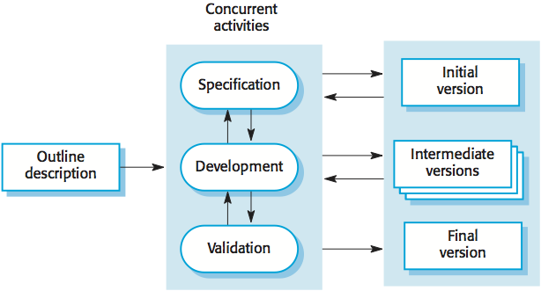  
  
  
  
  
  
  
  
  
  
  
  
  
**Figure1.1: Incremental Delivery Model**

The Incremental Delivery Model is an iterative software development approach that divides a project into small, functional segments known as increments. Each increment represents a part of the overall system's functionality and is developed, tested, and delivered independently. The development process begins with the most crucial features, allowing for the early delivery of core functionalities. Feedback is gathered after each increment, providing opportunities for adjustments and improvements. This iterative cycle continues until all increments are integrated into the final product. The Incremental Delivery Model offers flexibility, adaptability, and the ability to accommodate changes based on real-time feedback, making it an ideal choice for this project.

## **1.6 Report Organization**

**Chapter 1: Introduction**

This chapter serves as the gateway to our project, "Emergency Response System Using Dijkstra's Algorithm in the Context of the Kathmandu Valley." It provides a concise yet comprehensive overview of the project's significance, objectives, and the critical role it plays in optimizing emergency response efforts within the unique geographic landscape of the Kathmandu Valley.

**Chapter 2: Literature Review**

In this chapter, we delve into the existing body of knowledge surrounding emergency response systems, with a keen focus on projects employing Dijkstra's algorithm. The literature review aims to contextualize our project within the broader field, drawing insights from similar endeavors and setting the stage for the subsequent chapters by identifying relevant methodologies and challenges.

**Chapter 3: System Analysis**

This chapter undertakes a meticulous examination of the requirements and functionalities inherent to our project, "Emergency Response System Using Dijkstra's Algorithm in the Context of the Kathmandu Valley." By conducting a thorough system analysis, we aim to tailor our solution to the specific needs of users while considering geographical nuances and technological intricacies.

**Chapter 4: System Design**

Offering a deep dive into the intricacies of design, this chapter outlines the principles and architecture governing the "Emergency Response System Using Dijkstra's Algorithm in the Context of the Kathmandu Valley." From user interface considerations to structural components and data flow, this section lays the foundation for the subsequent implementation phase.

**Chapter 5: Implementation and Testing**

Embarking on the practical aspects of our project, this chapter details the actual development process of the "Emergency Response System Using Dijkstra's Algorithm in the Context of the Kathmandu Valley." By employing the incremental delivery model and adhering to robust coding practices and rigorous testing procedures, we ensure the reliability and functionality of our system.

**Chapter 6: Conclusion and Future Recommendations**

Bringing the narrative full circle, this concluding chapter synthesizes key findings, achievements, and challenges encountered during the development journey of "Emergency Response System Using Dijkstra's Algorithm in the Context of the Kathmandu Valley." It provides a comprehensive overview of the project's outcomes and their implications for the field of emergency response.

Looking beyond the immediate accomplishments, this chapter explores avenues for future growth and enhancement within the realm of "Emergency Response System Using Dijkstra's Algorithm in the Context of the Kathmandu Valley." By identifying potential improvements and features, we set the stage for continued innovation and adaptation to evolving needs

# **CHAPTER 2-BACKGROUND STUDY AND LITERATURE REVIEW**

## **2.1 Literature Review**

When an accident occurs, swift rescue operations are paramount, and finding the most time-efficient path to the destination is crucial for effective emergency response. Ni Kai, Zhang Yao-ting, and Ma Yue-peng (May 2014) discussed the limitations of relying solely on the shortest path, emphasizing that various factors impact travel time. They implemented an emergency response system based on GIS and Dijkstra's algorithm, providing optimal routes without considering road conditions and traffic congestion. The paper calls for further research to integrate real-time on-road traffic data for more dynamic, reliable, and accurate routes.

In July 2017, A. H. Eneh and U. C. Arinze evaluated several shortest path algorithms, including Dijkstra, A-search, restricted search, Bellman-Ford, Floyd-Warshall, and Gallo Pallottino graph growth algorithm. They eventually selected Dijkstra's SPA implemented with a double bucket data structure due to its fast and robust performance with linear run-time complexity. The study focused on route guidance applications for optimal results in emergency response and logistic planning. While A*-search is popular, its computational efficiency is bounded, making Dijkstra's algorithm a favorable choice.*

Ashok Kuppusamy (November 2016) highlighted the challenges of standard shortest path algorithms in dynamic and stochastic networks. The study found that the solution error of these algorithms is relatively small in certain conditions but may have a greater impact during incidents. The use of standard shortest path algorithms in dynamic traffic networks may be practically applicable, especially when travel time changes moderately. Kuppusamy proposed a route selection algorithm based on a driver's preference, using a FN approach to represent attribute correlation with the driver's route selection. This adaptive methodology, trained on the driver's choices, opens avenues for more intelligent navigation systems.

These studies collectively underscore the importance of considering diverse factors in emergency response routing, optimizing algorithms for real-time scenarios, and integrating adaptive systems for more effective navigation in dynamic environments. The proposed Emergency Response System using Dijkstra's Algorithm in the context of the Kathmandu Valley aligns with these research directions, aiming to address challenges and enhance efficiency in emergency services.

# **CHAPTER 3-SYSTEM ANALYSIS**

## **3.1 System Analysis**

System analysis, as used in software development, is the act of examining, comprehending, and recording the specifications, elements, and functionalities of a system. It entails disassembling a complicated system into smaller parts, analyzing the interactions between these parts, and determining the requirements that must be met for the system to achieve its goals.

### **3.1.1 Requirement Analysis**

Requirement analysis is the systematic process of gathering, documenting, and analyzing user needs and expectations for a software system. It involves identifying, refining, and prioritizing functional and non-functional requirements to serve as the basis for system design and development.

In essence, requirement analysis is crucial for establishing a clear understanding of what the software system needs to achieve and how it should perform, ensuring alignment with stakeholder expectations and project objectives.

#### **3.1.1.1 Functional Requirement**

A functional requirement defines the specific behavior or functionality that a software system must exhibit to meet user expectations and achieve its intended objectives.

Functional requirements for the project:

* Allow users to view their current location on the map.
* Automatically select the nearest ambulance.
* Allow the calculation and display of the optimal route from the user to the selected ambulance.
* Allow simulation and display of ambulance locations.
* Allow calculation and display of the optimal route from the incident location to the hospital.

This use case diagram outlines the interactions between the primary actor (User) and the secondary actor (System), encapsulating essential functionalities.

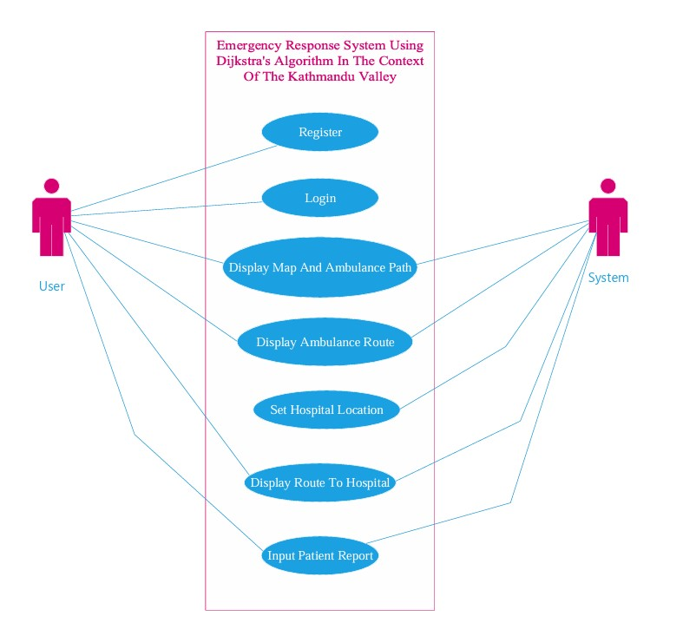

**Figure 3.1 Use Case Diagram of Emergency Response System**

**Use Case Description**

Here are some of the use case description of the project:

##### **Table 3.1 Use Case for Login**

|  |  |
| --- | --- |
| **Use Case ID** | UC-001 |
| **Use Case Name** | Login |
| **Primary Actor** | User |
| **Secondary Actor** | System |
| **Description** | User authentication and login to the system. |
| **Pre-Condition** | User has valid credentials. |
| **Success Scenario** | User successfully logs in. |
| **Failure Scenario** | Invalid Credentials, system error. |

##### **Table 3.2 Use Case for Register**

|  |  |
| --- | --- |
| **Use Case ID** | UC-002 |
| **Use Case Name** | Register |
| **Primary Actor** | User |
| **Secondary Actor** | System |
| **Description** | User registration for system access. |
| **Pre-Condition** | User provides valid registration information. |
| **Success Scenario** | User successfully registers. |
| **Failure Scenario** | Invalid registration data, system error. |

##### **Table 3.3 Use Case for Display Map and Ambulance Path**

|  |  |
| --- | --- |
| **Use Case ID** | UC-003 |
| **Use Case Name** | Display Map and Ambulance Path |
| **Primary Actor** | User |
| **Secondary Actor** | System |
| **Description** | Display map and ambulance path based on loaded on csv data. |
| **Pre-Condition** | CSV data successfully loaded. |
| **Success Scenario** | Map and path displayed. |
| **Failure Scenario** | CSV format error. |

##### **Table 3.4 Use Case for Display Ambulance Route**

|  |  |
| --- | --- |
| **Use Case ID** | UC-004 |
| **Use Case Name** | Display Ambulance Route |
| **Primary Actor** | User |
| **Secondary Actor** | System |
| **Description** | Showing the route from the user to the ambulance. |
| **Pre-Condition** | Ambulance is available. |
| **Success Scenario** | Route displayed successfully. |
| **Failure Scenario** | Ambulance not available. |

##### **Table 3.5 Use Case for Set Hospital Route**

|  |  |
| --- | --- |
| **Use Case ID** | UC-005 |
| **Use Case Name** | Set Hospital Route |
| **Primary Actor** | User |
| **Secondary Actor** | System |
| **Description** | Setting the hospital location for emergency routes. |
| **Pre-Condition** | User is authorized. |
| **Success Scenario** | Hospital location set by the system. |
| **Failure Scenario** | System error. |

##### **Table 3.6 Use Case for Display Route to Hospital**

|  |  |
| --- | --- |
| **Use Case ID** | UC-006 |
| **Use Case Name** | Display Route to Hospital |
| **Primary Actor** | User |
| **Secondary Actor** | System |
| **Description** | Displaying the optimal rote to the hospital. |
| **Pre-Condition** | Hospital location is set. |
| **Success Scenario** | Route to the hospital is displayed. |
| **Failure Scenario** | Hospital location is not set, route calculation error. |

##### **Table 3.7 Use Case for Input Patient Report**

|  |  |
| --- | --- |
| **Use Case ID** | UC-00 |
| **Use Case Name** | Input Patient Report |
| **Primary Actor** | User |
| **Secondary Actor** | System |
| **Description** | Entering patient information for emergency response. |
| **Pre-Condition** | User is logged in and an emergency is ongoing. |
| **Success Scenario** | Patient report successfully submitted. |
| **Failure Scenario** | User not logged in, system error during submission. |

#### **3.1.1.2 Non-functional Requirement**

A non-functional requirement specifies criteria that describe the operational characteristics, constraints, and qualities a system must possess, often related to performance, security, usability, and reliability.

Here are some of the non-functional requirement of the project.

**Performance:** Ensure the system provides real-time updates and responses for ambulance locations and routes.

**Security:** Implement secure authentication to protect user information and system integrity.

**Usability:** Design a user-friendly interface for easy interaction with the emergency response features.

### **3.1.2 Feasibility Analysis**

Feasibility analysis is a comprehensive evaluation of the practicality and viability of a project before its initiation. It involves assessing various dimensions to determine if the project is technically, operationally, economically, and schedule-wise feasible.

**Technical Feasibility:**

The project employs well-established web development technologies, including HTML, CSS, JS, Python, Flask, and SQLite. The decision to integrate the Leaflet API for mapping purposes demonstrates a practical approach to handling location-related features without relying on external map APIs.

**Operational Feasibility:**

The project prioritizes a user-centric design, aiming for a streamlined and effective emergency response. The automated selection of the nearest ambulance enhances operational efficiency, and the integration of ambulance, event, and hospital data from CSV files addresses practical operational needs.

**Economic Feasibility:**

While specific financial details are not provided, the project's reliance on widely used and open-source technologies suggests potential cost-effectiveness. The focus on a 5 km radius for ambulance selection and the absence of external mapping APIs contribute to potential cost efficiency.

**Schedule Feasibility:**

The provided Work Breakdown Structure (WBS) outlines a structured project plan with defined tasks, durations, and dependencies. The allocation of realistic durations and consideration of dependencies indicate a thoughtful approach to schedule feasibility, aligning with the scope of the project.

Here is the Work break down structure of the project:

##### **Table 3.8 Work Break Down Structure**

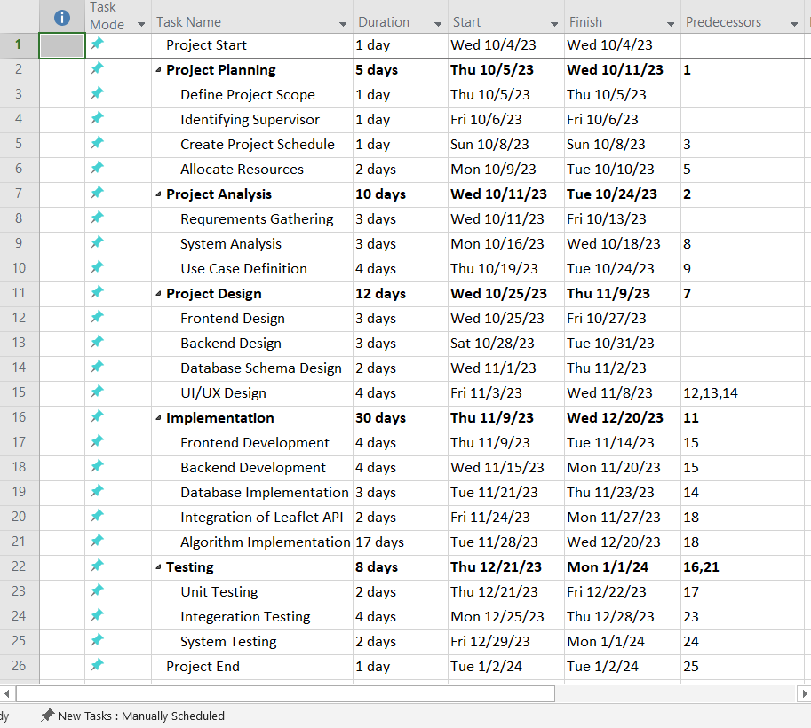

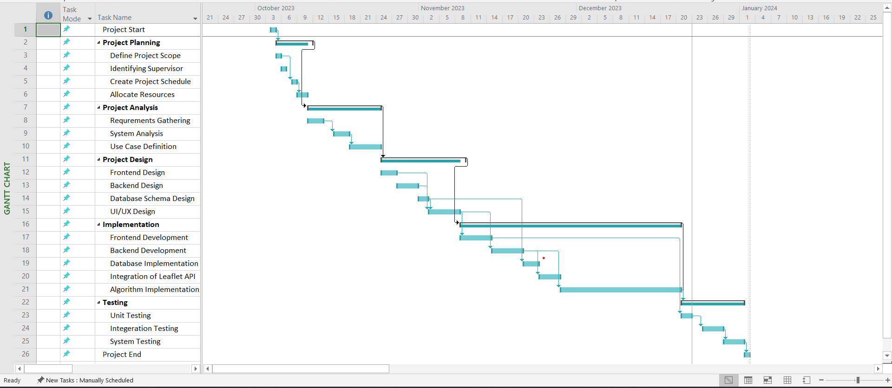

**Figure 3.2 Gantt Chart of the project**

### **3.1.3 Analysis**

The analysis phase forms the cornerstone of the Emergency Response System, establishing a foundational understanding through object modeling of core entities—ambulance, event, and hospital—and defining their attributes and relationships. Dynamic modeling reveals the system's dynamic behavior, elucidating transitions in ambulance states and detailed sequences like dispatching. Complementing this, process modeling offers an activity-centric view, presenting available ambulances to users, automated dispatching, real-time tracking, and concluding with a systematic end to the emergency response process. Together, these analyses provide a concise yet comprehensive blueprint for subsequent design phases, ensuring the efficacy of the emergency response system.

#### **3.1.3.1 Object Modeling (Class and Object Description):**

In defining core entities—ambulance, event, and hospital—attributes and relationships are established, providing a foundational understanding for subsequent design. Unique identifiers and associations delineate the essence of each entity, guiding the system's architectural structure.

**Ambulance:**

* Attributes: Unique Identifier (ID), Geographic Location, Status
* Relationships: Associated with Events, Dispatched to Hospitals

**Event:**

* Attributes: Unique Identifier (ID), Geographic Location, Event Type
* Relationships: Associated with Ambulances, Transported to Hospitals

**Hospital:**

* Attributes: Unique Identifier (ID), Geographic Location, Capacity
* Relationships: Reception of Ambulances, Reception of Transported Patients

#### **3.1.3.2 Dynamic Modeling (State and Sequence Description):**

Transitioning from static definitions, this phase focuses on dynamic states and interactions. Ambulance states, e.g., "Available" to "At Event," and detailed sequences, like dispatching, illuminate the system's dynamic behavior, offering insights into real-time events and transitions.

**State Description (for Ambulance):**

* The ambulance entity transitions through states such as "available," "en route," and "at event" based on dynamic conditions.

**Sequence Description (for Dispatching an Ambulance):**

* The dispatching sequence involves automatically assigning the nearest ambulance, updating its status, and confirming its arrival at the event, ensuring a systematic dispatching process.

#### **3.1.3.3 Process Modeling (Activity Description):**

Concluding the system analysis, the process modeling phase introduces an activity-centric view.

1. **Ambulance Display:**
   * Present available ambulances to the user without event notification.
2. **Dispatching:**
   * Automatically assign the nearest ambulance based on proximity algorithms and update its status.
3. **En Route:**
   * Continuously track ambulance locations and provide real-time status updates.
4. **At Event:**
   * Confirm the ambulance's arrival at the event and update its status.
5. **Transportation:**
   * Transport the patient from the event location to the designated hospital, updating records in both systems.
6. **End:**
   * Conclude the emergency response process, ensuring comprehensive record updates.

This structured activity-based approach ensures clarity in the operational workflow, specifically tailored to the presentation of ambulances to users and subsequent actions in the system.

# **CHAPTER 4-SYSTEM DESIGN**

## **4.1 Design**

The design of the system unfolds as a crucial stage where an object-oriented approach is employed to intricately weave analysis insights into a meticulously structured system architecture. This process entails the crafting of detailed class diagrams, the refinement of dynamic modeling concepts into clear state and sequence diagrams, and the seamless transition of process modeling into intuitive activity diagrams. The overarching objective is to architect a robust and scalable system, ensuring each design element resonates seamlessly with the project's requirements. This phase serves as a foundational stepping stone, setting the emotional groundwork for subsequent implementation and testing phases.

### **4.1.1 Class Diagram**

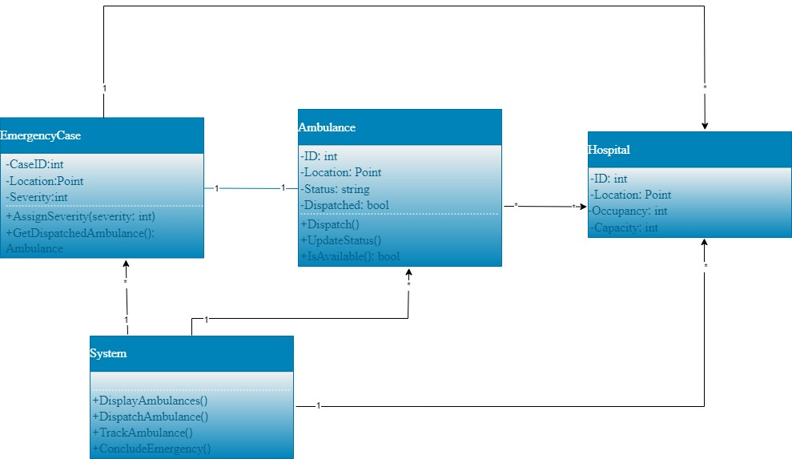The class diagram elucidates core relationships in the emergency response system. The pivotal "EmergencyCase" class governs key attributes, intricately linked with the "Ambulance" and "Hospital" classes for dispatch and patient transport. "Ambulance" encapsulates states and actions, while the overarching "System" orchestrates interactions. Dependencies and associations facilitate information flow, with "Transportation" relying on ambulance details. This guide establishes a foundational framework, enhancing coherence in subsequent design and implementation for an effective emergency response system.

**Figure 4.1 Descriptive Class Diagram of the system**

**4.1.2 Activity Diagram**

The activity diagram encapsulates the dynamic flow of the Emergency Response System, commencing with the "Start" node. It orchestrates user-driven actions such as login, ambulance viewing, event location setting, and patient report input. Transitioning into the "Process User Request" activity, the diagram manages authentication, ambulance display, and the coordination of emergency responses. At its core, the "Emergency Response Coordination" activity ensures seamless interactions between ambulances, users, and hospitals. Progressing to the "Hospital Process," it delineates patient reception, treatment, and overall hospital-related activities. The diagram concludes at the "End" node, providing a visual narrative of the system's comprehensive response mechanisms to user-initiated requests and emergency scenarios.

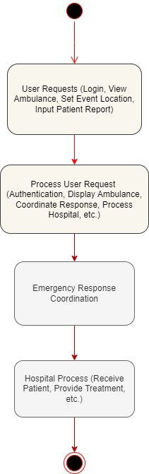Here is the Activity Diagram of the system

**Figure 4.2 Activity Diagram of the system**

### **4.1.3 Sequence Diagram**

The sequence diagram unfolds as a dynamic portrayal of interactions among the crucial classes: User, Ambulance, and Hospital within the Emergency Response System. Commencing with a user's request for ambulance assistance, the User class initiates a seamless flow of events. The Ambulance class promptly processes the request, updating its status and location in real-time. Subsequently, the Ambulance engages with the Hospital class, symbolizing the systematic handover of the patient. The Hospital class, in turn, acknowledges the incoming patient and proceeds with the necessary treatment. This succinct representation underscores the interplay of User, Ambulance, and Hospital, emphasizing their interconnected roles and the system's adept response in emergency scenarios.

Here is the sequence diagram of the system:

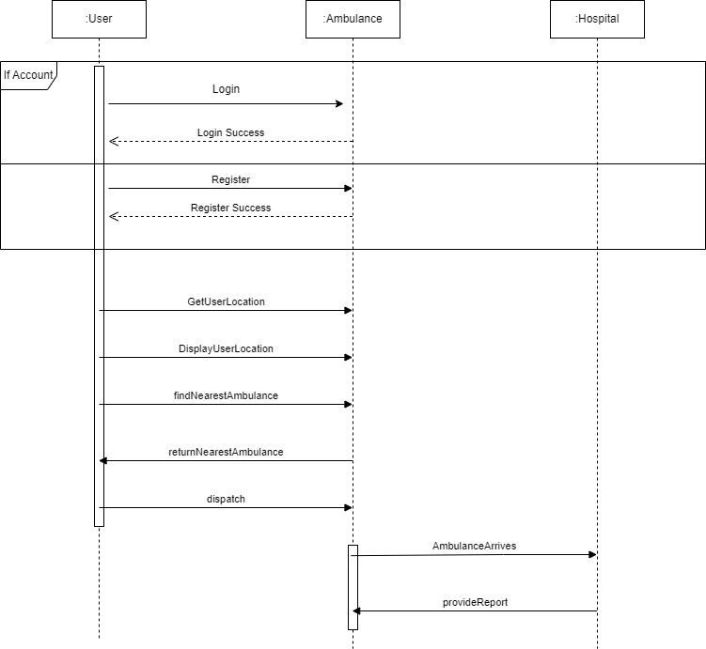

**Figure 4.3 Sequence Diagram of the System**

## **4.2 Algorithm Details**

The algorithmic framework of our Emergency Response System integrates three fundamental components to optimize ambulance routing and ensure efficient emergency response. Firstly, the Zone Classification and Priority Determination component categorizes geographical regions into distinct zones and assigns priority levels based on the demand for ambulance services. This strategic classification enables the system to allocate resources effectively, ensuring that ambulances are readily available in high-priority areas and dispatched promptly to address emergencies. Secondly, the Haversine formula is employed to calculate the distance between the accident event and both the hospital and the nearest ambulance. By accurately measuring these distances, the algorithm identifies the closest ambulance and hospital, facilitating swift response times and effective resource allocation.

Additionally, Dijkstra's algorithm plays a pivotal role in determining the shortest and most efficient path from the accident event to the nearest hospital. This graph-searching technique systematically explores potential routes within the road network, considering factors such as distance and road conditions, to optimize ambulance navigation and minimize response times. By integrating these components, our Emergency Response System enhances responsiveness and efficiency, ensuring timely assistance to individuals in need during emergencies.

### **4.2.1 Zone Classification and Priority Determination**

"Zone Classification and Priority Determination" is the process of dividing geographical locations into separate zones based on characteristics such as ambulance service demand, population density, and access to healthcare facilities. This categorization enables emergency response systems to better distribute resources by prioritizing regions with the greatest need for help.

The process involves evaluating a variety of characteristics to establish the priority level allocated to each zone. This involves looking at historical data on emergency situations, population demographics, transportation patterns, and geographical factors. By taking these characteristics into account, emergency response teams may more efficiently distribute resources to resolve problems in a timely way.

Here's a comprehensive overview of each zone:

**Red Zone (High Priority):**

* Designates areas characterized by the highest demand for ambulance services, typically due to a high volume of emergency incidents or critical medical needs.
* Urgent response is paramount to addressing emergencies promptly and effectively.
* Priority in the red zone is reinforced by allocating additional ambulances to ensure a swift and robust response to emergency situations.

**Blue Zone (Medium Priority):**

* Represents regions with a moderate demand for ambulance services where emergency incidents occur less frequently compared to red zones.
* Response times and resource allocation are managed with a balanced approach, ensuring that ambulances are available to address emergencies in a timely manner.
* Additional ambulances may be deployed during peak demand periods to maintain efficient operations and cater to increased service requests.

**Green Zone (Low Priority):**

* Indicates areas with minimal demand for ambulance services, characterized by fewer emergency incidents or lower population density.
* Response and resource allocation in green zones are less urgent compared to red and blue zones due to reduced demand for emergency assistance.
* Ambulance deployment in green zones is optimized to ensure efficient resource utilization, with a focus on maintaining readiness while minimizing unnecessary deployment.

Overall, zone classification and priority determination play a crucial role in optimizing emergency response systems, ensuring that resources are allocated where they are needed most and minimizing response times during critical situations.

### **4.2.2 Haversine Formula**

The Haversine Formula is a crucial component in geographical calculations, particularly in determining distances between two points on the Earth's surface. It is based on spherical trigonometry and provides an accurate approximation of the great-circle distance between two locations, considering the Earth as a sphere. The formula considers the latitude and longitude of both points and calculates the arc length along the surface of the sphere, representing the shortest distance between them. By employing trigonometric functions such as sine and cosine, the Haversine Formula encapsulates the curvature of the Earth's surface, ensuring precise distance calculations even over vast distances.

The Haversine Formula is:

distance = 2r * arcsin ( $\sqrt{sin^2(Δlat/2) + cos(lat1) * cos(lat2) * sin^2(Δlong/2)}$)

Where,

* r denotes the Earth's radius (typically taken as the mean radius, approximately 6,371 kilometers).
* lat1 and lat2 represent the latitudes of the two points.
* Δlat and Δlong signify the differences in latitudes and longitudes between the points.

Within the framework of this project, the Haversine Formula is crucial for determining distances between various geographical sites, such as accident event locations, ambulance positions, and hospitals. This formula uses latitude and longitude data to determine the nearest available ambulance and hospital to the accident scene. Such exact distance estimations are critical for minimizing emergency response times and providing timely and efficient medical care to those in need. Thus, within this project, the Haversine Formula serves as a foundation for successful ambulance routing and makes a substantial contribution to improving emergency service responsiveness.

### **4.2.3 Dijkstra’s Algorithm**

Dijkstra’s Algorithm, a fundamental graph-searching algorithm, stands as a pivotal tool for determining the shortest path between nodes in a weighted graph. Developed by Edsger Dijkstra, this algorithm excels in scenarios where efficient route optimization is critical. It operates by assigning tentative distances to nodes, progressively updating them to uncover the most optimal path. Central to its effectiveness is its adaptability to weighted graphs, where edges carry numerical weights representing distances or costs.

The algorithm commences at a designated starting node and iteratively explores neighboring nodes, systematically updating distances and marking visited nodes. By prioritizing nodes with the shortest tentative distance, Dijkstra’s algorithm ensures the identification of the optimal path to all other nodes in the graph. Its widespread application in diverse fields underscores its versatility, making it a key solution for route optimization in transportation, network systems, and, notably, in enhancing ambulance navigation efficiency within the Emergency Response System.

#### **Key Components:**

1. **Priority Queue (Q):** The algorithm maintains a priority queue to efficiently select the node with the smallest tentative distance for exploration in each iteration.
2. **Distance Array (dist):** An array to store the tentative distances from the start node to each node in the graph. It is initialized with infinity for all nodes except the start node, which is set to 0.

#### **Steps:**

# Dijkstra’s Algorithm Pseudocode

# Initialization  
Q = Priority Queue containing all nodes  
dist = Array of tentative distances, initialized to infinity for all nodes, except start node set to 0

# Main Loop  
while Q is not empty:  
    # Select node with the smallest dist value  
    current = Node with the smallest dist value from Q  
    remove current from Q

    # Neighbor Exploration  
    for neighbor in neighbors of current:  
        alt = dist[current] + distance (current, neighbor)  
        if alt < dist[neighbor]:  
            dist[neighbor] = alt

    # Priority Queue Update  
    Remove current from Q

# Algorithm Completion  
# Array 'dist' contains the shortest distances from the start node to all other nodes

#### **Time and Space Complexity:**

* **Time Complexity:** The time complexity is influenced by the priority queue implementation. With a Fibonacci heap, the time complexity is typically O ((V + E) * log V), where V is the number of nodes and E is the number of edges.
* **Space Complexity:** The space complexity is O (V + E), dominated by the storage of distances and adjacency information.

#### **Adaptability:**

Dijkstra's algorithm adapts well to dynamic scenarios, making it suitable for real-time applications. It consistently explores and updates the shortest paths, allowing for responsive adjustments in the event of changes in the graph, such as road closures or traffic updates.

#### **Optimality:**

The algorithm ensures optimality by always selecting the node with the smallest tentative distance. This property guarantees that once a node is marked as visited, its distance is finalized, ensuring the shortest path.

#### **Application in the Emergency Response System:**

In the framework of the Emergency Response System, Dijkstra’s algorithm emerges as a key component for optimizing ambulance routing. This algorithm, designed to find the shortest path in a weighted graph, aligns seamlessly with the system's goal of ensuring swift and efficient emergency responses. In the context of the project, the graph represents the network of roads connecting event locations, ambulances, and hospitals.

When an emergency event occurs, Dijkstra’s algorithm becomes instrumental in identifying the shortest route for an ambulance to reach the event location swiftly. By assigning weights to the road segments based on distance or travel time, the algorithm systematically explores the network, prioritizing paths that minimize travel time. This meticulous calculation ensures that ambulances are dispatched via the most optimal route, reducing response times and maximizing efficiency.

The algorithm's adaptability to varying road conditions and real-time updates makes it well-suited for the dynamic nature of emergency response scenarios. As it navigates through the graph, it not only determines the shortest path to the event location but also efficiently identifies alternative routes in case of road closures or congestion. This versatility ensures a robust and responsive ambulance navigation system within the Emergency Response System, contributing significantly to the project's overall efficacy. The time and space complexities of Dijkstra’s algorithm are carefully managed, ensuring scalability and performance within the operational constraints of the Emergency Response System.

# **CHARPTER 5-IMPLEMENTATION AND TESTING**

## **5.1 Implementation**

System implementation is the process of converting the project's requirements and conceptual design into actual software components. This phase includes a number of tasks, such as coding, which involves writing the actual code based on the system design; integration, which involves combining various modules and components to create a cohesive system; and testing, which involves assessing the system to make sure it satisfies the requirements and operates as intended. In order to prepare the program for operational usage, system implementation may also entail configuring, installing, and deploying it in the target environment.

### **5.1.1 Tools Used**

The following are the tools used for document design and project implementation:

**Implementation Tools:** Implementation tools are those that support the project's overall execution. The front-end, back-end, and algorithmic development of a system were all developed using different tools. They are as follows:

##### **Table 5.1 Tools Used for Development of a System**

|  |  |  |
| --- | --- | --- |
| **Category** | **Tool/Technology** | **Description** |
| Front-end | HTML5 (Hypertext Markup Language) | Latest version of the standard markup language for creating and structuring web pages and applications. Provides new features for multimedia support, semantic tags, and improved SEO. |
| Front-end | CSS3 (Cascading Style Sheets) | Latest iteration of the style sheet language for controlling the presentation and layout of web pages. Introduces features like rounded corners, gradients, shadows, and animations, enabling visually appealing and responsive designs. |
| Front-end | JavaScript | Versatile programming language for adding interactivity and dynamic behavior to web pages. Enables manipulation of HTML/CSS, handling user interactions, creating animations, form validation, and asynchronous data fetching. |
| Front-end | Bootstrap 5 | Popular front-end framework simplifying responsive and mobile-first web development. Offers pre-designed components, responsive grid system, and utility classes for consistent layouts across devices. |
| Back-end | Python (v3.12.0) | Versatile and high-level programming language known for simplicity and readability. Widely used in web development for back-end logic, data processing, and algorithm implementation. |
| Back-end | Flask (v3.0.0) | Lightweight and extensible web framework for Python. Simplifies web application development with features like routing, request handling, template rendering, and session management. Suitable for scalable and maintainable back-end systems. |
| Back-end | SQLite (v3) | Lightweight, serverless, self-contained relational database management system for local storage and small-scale applications. Provides efficient data storage and retrieval with support for standard SQL syntax, transactions, indexes, and triggers. |
| Development | Visual Studio Code (VS Code) | Lightweight yet powerful code editor developed by Microsoft. Offers extensive customization options, support for various programming languages, syntax highlighting, code completion, and an integrated terminal for enhanced developer productivity. Cross-platform support ensures consistency across different operating systems. |

**Algorithm Development Tools**

The tool used for the development of the algorithm is:

**Google Colaboratory**

Colab, often referred to as Google Colaboratory, is a cloud-based platform that Google offers that lets users build and run Python programs in a group setting. It offers a hosted Jupyter notebook interface on Google's servers, obviating the requirement for setup or local installation. With the help of robust processing resources like GPUs and TPUs, users may efficiently execute their programs. Google Drive and Colab work together flawlessly to make project sharing and collaboration simple. Because it supports a large variety of libraries and frameworks frequently used in data analysis and machine learning, it is a well-liked option for activities demanding computing resources in research, teaching, and development.

**Git (v** **2.43.0.windows.1) and GitHub**

Git is a distributed version control system that enables developers to track changes in source code during software development. It allows users to create repositories, branch off from existing code, make modifications, and merge changes back into the main codebase. Developers can work on their local copies of a repository, make changes, and then synchronize these changes with a central repository or with other developers' copies. Git provides features such as branching, merging, and version history tracking, which are essential for managing code changes in a collaborative environment. It allows teams to work on different features simultaneously without interfering with each other's work and provides a robust mechanism for resolving conflicts that may arise during the development process.

GitHub is a web-based platform that hosts Git repositories and provides additional features for collaboration, project management, and code hosting. It allows developers to share their code publicly or privately, collaborate with others through pull requests and issues, and track project milestones using features like project boards and wikis. GitHub facilitates social networking among developers, enabling them to follow each other, star repositories, and contribute to open-source projects. It also offers integration with various third-party services and tools, making it a central hub for software development workflows. Overall, GitHub enhances the capabilities of Git by providing a user-friendly interface and additional features for managing and collaborating on software projects.

**CASE Tools**

CASE Tools (Computer-Aided Software Engineering Tools) are software applications specifically designed to assist in various stages of the software development life cycle (SDLC). These tools provide support for tasks such as requirements analysis, design, coding, testing, and maintenance, helping developers and teams streamline their development processes and improve overall productivity. The CASE tools used in this project are:

**Draw.io**

Draw.io is a web-based diagramming tool that allows users to create various types of diagrams, including flowcharts, network diagrams, UML diagrams, and more. It provides a user-friendly interface with a wide range of shapes, symbols, and connectors, enabling users to visually represent their ideas, processes, and system architectures. Draw.io supports collaboration features, allowing multiple users to work on diagrams simultaneously and share them with others. It is widely used in software development for designing system architectures, documenting workflows, and creating visual representations of software components.

**Microsoft Project 2019**

Microsoft Project 2019 is a project management software application that helps users plan, track, and manage projects effectively. It provides features for creating project schedules, allocating resources, setting milestones, and tracking progress against predefined goals. Microsoft Project offers various views and tools for visualizing project data, such as Gantt charts, task lists, and resource graphs, allowing project managers to monitor project status and make informed decisions. It also supports collaboration among team members, enabling them to share project documents, communicate updates, and coordinate tasks. Microsoft Project is widely used in software development projects for managing project timelines, resource allocation, and budget tracking, ensuring successful project delivery within scope, time, and budget constraints.

**Dependencies**

**Dependencies** in software development refer to external components or libraries that a project relies on to function properly. These dependencies can include frameworks, libraries, modules, packages, or other software components that are not developed as part of the project itself but are required for its operation. The dependencies used in this project are:

* 1. **Python Built-in modules**

Python's built-in modules provide essential functionality for various tasks within a Python environment. These modules come pre-installed with the Python interpreter, offering a wide range of features and tools to developers. The built-in Python modules used in this project are:

##### **Table 5.2 Built-in Python modules**

|  |  |  |
| --- | --- | --- |
| **S. N** | **Python Built-in Modules** | **Purpose** |
| **1.** | **concurrent.futures** | This package was employed to enable asynchronous processing and parallel execution of tasks. |
| **2.** | **ast** | This package was used to provide a parser and a generator of Abstract Syntax Trees (ASTs) for Python code. |
| **3.** | **io.BytesIO** | This package provided a stream interface for in-memory binary data. |

* 1. **External module**

External modules are third-party libraries or packages that expand the capabilities of Python beyond its standard library. They offer a diverse range of tools for tasks such as data manipulation, web development, and scientific computing. By incorporating these modules into their projects, developers can enhance productivity and access advanced functionalities without having to develop everything from scratch. These modules are easily installable via package managers like pip and benefit from continuous community development, ensuring robustness and reliability in Python-based applications.

##### **Table 5.3 External Module used in project**

|  |  |  |
| --- | --- | --- |
| **S. N** | **External Module** | **Purpose** |
| **1.** | flask_login | This package was used for handling user authentication, login, and session management. |
| **2.** | werkzeug.security | This package was used to provide utilities for generating and checking password hashes. |
| **3.** | flask_sqlalchemy | This package was integrated with Flask for database management using SQLAlchemy |
| **4.** | Secrets | This package was utilized to generate secure random tokens for CSRF protection and session management. |
| **5.** | Pandas | This package was employed for data manipulation and analysis, particularly for handling CSV data. |
| **6.** | Numpy | This package was used to support mathematical operations and array manipulation. |
| **7.** | shapely.geometry | This package was used for geometric operations, especially for geographical calculations. |
| **8.** | Reportlab.pdfgen | This package facilitated the generation of PDF documents, particularly for creating patient reports. |
| **9.** | Flask | This package was utilized to implement the Flask web framework for building web applications. |
| **10.** | Osmnx | This package is used to retrieve detailed geographical data of Kathmandu, including street networks, building footprints, and points of interest, facilitating route planning and spatial analysis. |

**Hardware configuration**

Two hardware setups were employed in the development of the algorithm for this project. The specifics of the system configuration that was put into practice are as follows:

##### **Table 5.4 Hardware configuration used in project**

|  |  |  |
| --- | --- | --- |
| **Machines** | **Machine I** | **Machine II** |
| Operating System | Windows 11 Pro | Windows 11 Pro |
| Processor | Intel(R) Core(TM) i5-8250U CPU @ 1.60GHz 1.80 GHz | Intel Core i7-5500U @ 2.40 GHz |
| Physical / Total Cores | 4/8 | 2/4 |
| Main Memory | 4GB | 8GB |
| Disk Space | 1TB | 256GB |

## **5.1.2 Implementation Details**

The Emergency Response System's particular processes and algorithms—such as zone classification, ambulance assignment, shortest path computation, hospital data retrieval, PDF report production, and user authentication—are described in detail in the section titled "Implementation Details." Every action enhances the system's performance and guarantees prompt and effective emergency response procedures. Here's a diagram that depicts the detailed implementation of an algorithm.

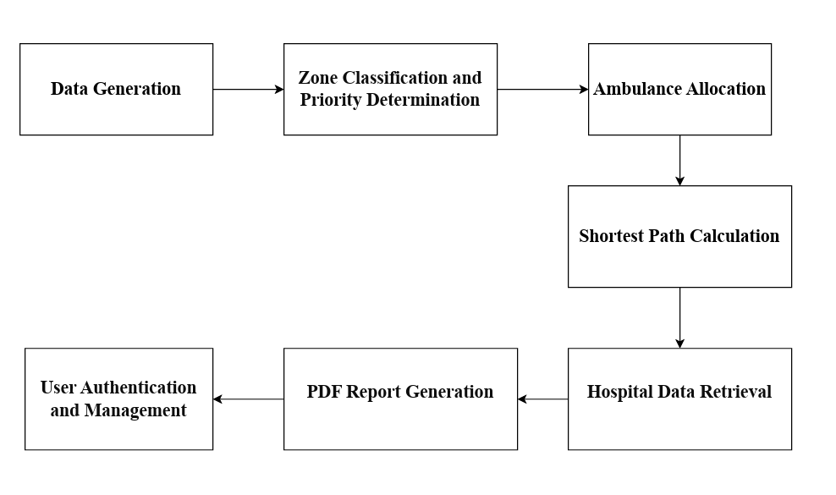

**Figure 5.1 Algorithm Implementation Procedure**

**Data Generation**

During the first phase of implementation, the system creates synthetic data to replicate emergency situations, hospital locations, and ambulance availability. This synthetic data provides a framework for testing and evaluating the system's functioning without relying on real-time data sources.

The following is the data that has been generated:

**Ambulance Data Generation**

Synthetic data for ambulance entities is generated to mimic real-world scenarios within the system. This process involves:

* Creating random values for attributes such as ID, longitude, latitude, availability, license plate, and mobile number using Python libraries or functions.
* Ensuring that the generated data reflects a realistic distribution of ambulance availability and locations.
* Considering factors such as geographic coverage and population density to distribute ambulance locations effectively.

##### **Table 5.5 Data columns-ambulance_data.csv**

|  |  |  |
| --- | --- | --- |
| **Column** | **Data Type** | **Data Range** |
| ID | Numeric | Unique identifiers for ambulances |
| Longitude | Float | Geographic longitude coordinates |
| Latitude | Float | Geographic latitude coordinates |
| Availability | Categorical | Availability status (Available/Not Available) |
| License Plate | String | License plate numbers of ambulances |
| Mobile Number | String | Contact numbers for ambulance operators |

**Event Data Generation:**

Synthetic data for emergency events is generated to simulate various types of incidents that might occur within the system. This process involves:

* Generating random event IDs, longitude, latitude, timestamps, and event types (e.g., fire, accident, medical emergency) using Python functions or libraries.
* Incorporating realistic patterns and distributions to reflect the occurrence of different types of emergencies in different geographic areas.
* Considering factors such as time of day, day of the week, and historical data trends to generate plausible event timestamps and types.

##### **Table 5.6 Data columns-event _data.csv**

|  |  |  |
| --- | --- | --- |
| **Column** | **Data Type** | **Data Range** |
| Event ID | Numeric | Unique identifiers for emergency events |
| Longitude | Float | Geographic longitude coordinates |
| Latitude | Float | Geographic latitude coordinates |
| Timestamp | DateTime | Timestamp of the event occurrence |
| Type | Categorical | Type of emergency event (Fire, Accident, etc.) |

**Hospital Data Generation:**

Real data for hospital entities is utilized to represent the locations and details of hospitals within the system. This process involves:

* Acquiring publicly available data or manually creating a dataset containing information about hospital names, addresses, phone numbers, and geographic coordinates.
* Ensuring the accuracy and reliability of the hospital data by validating it against authoritative sources or official records.
* Preprocessing the hospital data to ensure consistency and compatibility with the system's data format and structure.

##### **Table 5.7 Data columns-hospital _data.csv**

|  |  |  |
| --- | --- | --- |
| **Column** | **Data Type** | **Data Range** |
| Name | String | Name of the hospital |
| Address | String | Address of the hospital |
| Phone | String | Contact number of the hospital |
| Latitude | Float | Geographic latitude coordinates |
| Longitude | Float | Geographic longitude coordinates |

**Zone Classification and Priority Determination**

In the process of zone classification and priority determination, the system assigns event locations into three distinct zones: red, blue, and green, each with specific criteria and priority levels. The classification process involves the following steps:

1. **Zone Definition**: Define criteria for each zone based on factors such as population density, traffic congestion, and proximity to healthcare facilities. For example, red zones may represent areas with high population density and limited access to medical resources, while green zones may indicate low-density areas with sufficient healthcare infrastructure.
2. **Geospatial Analysis**: Utilize geospatial analysis techniques to analyze event locations in relation to predefined criteria. Geographic information systems (GIS) tools can be employed to assess factors such as distance to hospitals, road networks, and population distribution.
3. **Zone Assignment**: Assign event locations to the appropriate zone based on the analysis results. This assignment may involve the use of algorithms or rule-based systems to determine the zone classification for each event.
4. **Priority Determination**: Once event locations are classified into zones, prioritize response efforts based on the severity and urgency of events within each zone. For example, red zones may receive higher priority due to the critical nature of emergencies occurring in densely populated areas with limited resources.
5. **Resource Allocation**: Allocate emergency response resources such as ambulances and medical personnel based on the zone classifications and priority levels. Ensure that resources are distributed efficiently to address the needs of each zone effectively.

By including the zone data generation process, the system can accurately classify event locations and prioritize emergency responses based on the severity and urgency of each incident and its geographical context.

Here's a table describing the zone data generation process:

##### **Table 5.8 Data columns-zone_data.csv**

|  |  |  |  |
| --- | --- | --- | --- |
| **Data Attribute** | **Description** | **Data Type** | **Range/Example** |
| Zone Type | Type of zone indicating its priority level | Categorical | Red, Blue, Green |
| Latitude | Latitude coordinate of the zone | Numerical | Range: -90 to 90 degrees |
| Longitude | Longitude coordinate of the zone | Numerical | Range: -180 to 180 degrees |

**Ambulance Allocation**

When the system receives an accident occurrence, it commences a vital procedure that quickly assigns the nearest available ambulance to the event location, providing immediate medical response and potentially lifesaving intervention. This complex allocation system consists of multiple involved steps:

1. **Event Triggering and Data Acquisition:** The system is triggered when an accident event occurs, providing crucial information such as precise location coordinates and pertinent event details. This data serves as the foundation for subsequent allocation decisions.
2. **Utilization of the Haversine Formula:** Leveraging the Haversine formula, the system meticulously calculates the distance between the accident site and each ambulance's current location. This sophisticated mathematical model accurately computes the great-circle distance on the Earth's surface, considering the curvature of the planet, to determine proximity.
3. **Search Radius Expansion Strategy:** The allocation process adopts a strategic search radius expansion strategy, initially focusing on a radius of 1 kilometer around the event location. In the absence of available ambulances within this range, the system systematically expands the search radius in incremental steps, typically up to 5 kilometers, to comprehensively cover the surrounding area.
4. **Availability Assessment:** For each defined search radius, the system meticulously assesses the availability status of all registered ambulances within that geographic scope. Ambulances marked as "available" are considered prime candidates for allocation, prioritizing vehicles ready for immediate deployment.
5. **Proximity-Based Prioritization:** Employing a sophisticated prioritization algorithm, the system strategically ranks ambulances based on their proximity to the accident site. Closer ambulances are inherently prioritized over those located farther away, optimizing response time and minimizing delays in reaching the scene.
6. **Dynamic Allocation Decision-Making:** Using preset parameters, the system autonomously evaluates ambulances that are available within the chosen search radius. It determines the best candidate for allocation using an analytical procedure that considers variables like the availability of ambulances and geographic proximity. This paradigm for decision-making places proximity above everything else in order to minimize reaction time and facilitate effective resource allocation in emergency situations.
7. **Dispatch Confirmation and Route Optimization:** Upon finalizing the allocation decision, the system promptly confirms the dispatch of the selected ambulance to the accident location. Concurrently, route optimization algorithms may be employed to calculate the most efficient path for the ambulance, considering factors such as traffic congestion, road conditions, and potential obstacles.
8. **Continuous Monitoring and Adaptive Strategies:** Throughout the allocation process, the system continuously monitors ambulance availability and dynamically adjusts search parameters as needed. In the event of changing circumstances or resource constraints, the system employs adaptive strategies to ensure timely and effective ambulance allocation.

**Shortest Path Calculation**

These are the procedures that this project follows in order to determine the shortest path.

**1.** **Algorithm Selection:**

The system employs Dijkstra's algorithm for computing the shortest path between locations within the Kathmandu road network. This algorithm is chosen for its efficiency in finding the optimal route based on distance.

**2.** **Ambulance Route Planning**:

When an emergency event occurs, the system utilizes Dijkstra's algorithm to calculate the shortest path from the ambulance's current location to the event site. This route ensures rapid response and minimizes travel time.

**3.** **Event to Hospital Routing:**

After the ambulance reaches the event location, another shortest path calculation is performed to determine the most efficient route from the event site to the nearest hospital. This ensures timely transportation of patients to medical facilities.

**4.** **Geographic Data Utilization:**

OSMnx library is instrumental in providing detailed geographic data of the Kathmandu road network. This data, structured as a MultiDiGraph with 23,588 nodes and 58,136 edges, enables accurate route calculation by incorporating real-world road connectivity and topology.

**5.** **Graph Representation:**

The road network data obtained from OSMnx forms the basis of the graph representation used in Dijkstra's algorithm. Nodes represent specific geographic locations, while edges denote road segments connecting these locations, facilitating precise route planning.

**6. Computational Efficiency:**

Dijkstra's algorithm efficiently explores the road network graph to find the shortest path between locations. By leveraging priority queues and greedy selection of nodes, it ensures optimal route calculation even for large-scale road networks.

**7. Real-time Path Visualization:**

The calculated shortest paths are visually depicted on the map interface using Leaflet API. This real-time visualization allows emergency responders to track ambulance movements and plan subsequent actions effectively.

Dijkstra's algorithm, integrated with the geographic data obtained from OSMnx, forms the backbone of the shortest path calculation process in the system. By systematically evaluating possible routes within the Kathmandu road network, the algorithm facilitates efficient ambulance dispatch and patient transportation, thereby enhancing the overall effectiveness of emergency response operations. Through continuous validation and optimization, the system ensures that the computed routes align with real-world conditions, enabling prompt and reliable assistance during critical situations.

**Hospital Data Retrieval**

These are the procedures that this project follows for the hospital data retrieval:

**1. Geographic Proximity Determination**:

Upon receiving an emergency event, the system employs the Haversine formula to calculate the distance between the event location and various hospitals within the Kathmandu area. This distance computation enables the identification of the nearest hospital to the event site.

**2. Data Source Utilization**:

Hospital data, containing information such as hospital names, addresses, phone numbers, and geographic coordinates, is sourced from a predefined dataset. This dataset, manually created or obtained from authoritative sources, serves as the primary repository of hospital information for the system.

**3. Haversine Formula**:

The Haversine formula, a mathematical equation used for calculating distances between two points on a sphere, is applied to determine the geographic proximity of hospitals to the event location. By considering the curvature of the Earth's surface, this formula provides accurate distance measurements essential for identifying the nearest hospital.

**4. Concurrent Processing**:

To expedite the hospital data retrieval process, the system leverages the concurrent.futures module in Python. By utilizing concurrent execution mechanisms such as ThreadPoolExecutor, the system achieves parallel processing of hospital data queries, resulting in improved performance and reduced response times.

**5. Asynchronous Query Execution**:

Concurrent processing techniques enable asynchronous execution of hospital data queries, allowing multiple queries to be executed simultaneously. This parallelized approach enhances system responsiveness and scalability, particularly in scenarios involving a high volume of concurrent requests.

**6. Optimized Resource Allocation**:

Through concurrent processing, system resources are efficiently utilized to handle hospital data retrieval tasks. By distributing computational workloads across multiple threads or processes, the system maximizes resource utilization, minimizing bottlenecks and optimizing overall system performance.

**7. Real-time Hospital Selection**:

The nearest hospital, identified through the Haversine distance calculation and concurrent data retrieval, is dynamically selected based on its proximity to the event location. This real-time selection ensures timely dispatch of emergency medical services, prioritizing patient care and response effectiveness.

Hospital data retrieval in the system is a critical component of the emergency response process, facilitating the rapid identification and selection of medical facilities for patient treatment. By leveraging the Haversine formula and concurrent processing techniques, the system achieves accurate and efficient hospital data retrieval, enabling timely dispatch of ambulances to the nearest healthcare facilities. The integration of asynchronous query execution and optimized resource allocation enhances system scalability and responsiveness, ensuring robust performance even under high-demand scenarios. Overall, hospital data retrieval capabilities contribute to the system's ability to deliver prompt and effective emergency medical services, thereby enhancing public safety and well-being.

**PDF Report Generation**

The PDF report generation module is an integral component of the system, delivering detailed reports to medical professionals, particularly doctors, to aid in understanding emergency situations and guiding informed decision-making. By amalgamating data from various sources, such as event specifics, ambulance dispatch records, and patient condition, the system dynamically produces tailored reports for each emergency, ensuring comprehensive information dissemination.

* Integration of data from diverse sources like event details and patient condition facilitates the generation of comprehensive reports.
* Utilization of Reportlab.pdfgen library and io.BytesIO module ensures visually appealing and easily comprehensible reports.
* Seamless integration with the Flask framework allows direct access and download of reports from the web interface, enhancing distribution efficiency.

Essentially, the PDF files serve as a mainstay for improving medical professionals' ability to communicate, work together, and make better decisions. By using these data, medical professionals may more effectively assess emergency situations and provide prompt, appropriate care, improving the standard of patient care.

**User Authentication and Management**

The project incorporates robust user authentication and management features to ensure system security and protect sensitive user data. Leveraging Werkzeug.security for password hashing with the pbkdf2:sha256 algorithm and a salt length of 8 enhances password security significantly.

* Integration of Flask's user authentication features, including login forms, user sessions, and password hashing utilities, ensures a smooth and secure login experience.
* User management capabilities empower administrators to manage user accounts, enforce access control policies, and maintain data integrity and confidentiality.

The system not only conforms with security standards but also protects user credentials against unwanted access and exploitation by using industry-standard cryptographic algorithms and best practices for user authentication. By taking a complete approach to user management and authentication, the system is built on a secure basis that guarantees the integrity and confidentiality of user data.

## **5.2 Testing**

The testing process involves discovering and correcting flaws and mistakes. The testing procedure takes place concurrently with the system's implementation. The goal of testing is to show the anticipated functionality and discover any deviations from that behavior. This ensures that flaws are addressed before a software program is released for use.

#### **5.2.1 Test Cases for Unit Testing**

Unit testing is a pivotal part of software development, focusing on verifying individual code components' correctness and functionality in isolation. It ensures that each module operates as intended, identifies bugs early, and maintains code integrity, thereby enhancing system reliability. Test cases validate specific functionalities, ensuring they meet requirements and specifications, facilitating code refactoring and overall system stability.

**Test Case for Applicant Register**

##### **Table 5.9 Test Case for Applicant Register**

|  |  |  |  |  |  |  |  |  |  |
| --- | --- | --- | --- | --- | --- | --- | --- | --- | --- |
| **Test Case Name** | | | **APPLICANT REGISTER** | | **Test Case ID** | | | **TC-01** | |
| Test Case Description | | | Test Case for Applicant Register | | Test Priority | | | High | |
| Prerequisite | | | Provide first name, last name, phone number, email, and matching password confirmations upon submission of the registration form. | | Post-Condition | | | The user is stored in a database and successfully the account should be validated; session details are logged in to the account. | |
|  | **Test Execution Steps:** | | |  | |  |  | |  |
| **S.N.** | **Action** | **Test Steps** | | | | **Expected Output** | **Actual Output** | | **Test Result** |
| 1. | Navigation to Applicant Registration |  | | | | Application should be able to Register | Applicant is navigated to Home Page | | Pass |
| 2. | Verify that a new applicant can successfully register. | Provide applicant First Name: “Ankit”, Last Name: Shrestha, Email: “ankit.shrestha196@gmail.com”, Phone: 9819309246, Password: “EmpowerL1ght” | | | | Navigate to the Home page | Navigate to the Home page | | Pass |
| 3. | Verify that an applicant cannot register with an email that already exists. | Provide applicant First Name: “Ankit”, Last Name: Shrestha, Email: “ankit.shrestha196@gmail.com”, Phone: 9819309246, Password: “EmpowerL1ght” | | | | Display message: “That email does not exist, please try again.” And Navigate to login page | Display message: “That email does not exist, please try again.” And Navigate to login page | | Pass |

**Test Case for Applicant Login**

##### **Table 5.10 Test Case for Applicant Login**

|  |  |  |  |
| --- | --- | --- | --- |
| **Test Case Name** | **APPLICANT LOGIN** | **Test Case ID** | **TC-02** |
| Test Case Description | Test Case for Applicant Login | Test Priority | High |
| Prerequisite | An applicant's account must be registered. | Post-Condition | The system should authenticate the user's credentials and redirect them to the home page. |

|  |  |  |  |  |  |  |
| --- | --- | --- | --- | --- | --- | --- |
|  | **Test Execution Steps:** | |  |  |  |  |
| **S.N.** | **Action** | **Test Steps** | | **Expected Output** | **Actual Output** | **Test Result** |
| 1. | Navigation to Applicant Login Page |  | | Application should be able to access login page | User is navigated to the login page | Pass |
| 2. | An applicant's account must be registered. | Input valid email: “ankit.shrestha196@gmail.com” and password:” EmpowerL1ght”. | | Successful login and redirection to the home page. | User successfully logs in and is redirected to the home page. | Pass |
| 3. | An applicant's account must be registered. | Input invalid email: “ankit.crestha196@gmail.com” and valid password:” EmpowerL1ght”. | | That email does not exist; please try agai | That email does not exist; please try again. | Pass |
| 4. | An applicant's account must be registered. | Input valid email: “ankit.shrestha196@gmail.com” and invalid password:” EmpowerL1ght”. | | Password incorrect, please try again. | Password incorrect, please try again. | Pass |

**Test Case for Ambulance Allocation**

##### **Table 5.11 Test Case for Ambulance Allocation**

|  |  |  |  |  |  |  |  |  |  |  |
| --- | --- | --- | --- | --- | --- | --- | --- | --- | --- | --- |
| **Test Case Name** | | | **AMBULANCE ALLOCATION** | | **Test Case ID** | | | **TC-03** | | |
| Test Case Description | | | Test Case for Ambulance Allocation | | Test Priority | | | High | | |
| Prerequisite | | | Ambulance data must be available in the system. | | Post-Condition | | | The test case should be that an ambulance is successfully allocated to the event location within the specified radius, ensuring a timely response to emergencies. | | |
|  | **Test Execution Steps:** | | |  | |  |  | |  |
| **S.N.** | **Action** | **Test Steps** | | | | **Expected Output** | **Actual Output** | | **Test Result** |
| 1. | Navigation to map route |  | | | | Application should be able to access map page. | User is navigated to the map page. | | Pass |
| 2. | Ambulance data must be available in the system. | Event coordinates: Latitude: “27.677202” longitude: “ 85.327903”. | | | | Nearest available ambulance allocated.  Ambulance Coordinate: Latitude: “27.689249” longitude: “85.314609”. | Ambulance dispatched to event location. | | Pass |
| 3. | Ambulances within the radius marked as unavailable | Event coordinates: Latitude: “27.677202” longitude: “ 85.327903”. | | | | We're sorry, but no ambulance is available nearby. Help is on the way! | We're sorry, but no ambulance is available nearby. Help is on the way! | | Pass |

**Test Case for Shortest Path Calculation**

##### **Table 5.12 Test Case for Shortest Path Calculation**

|  |  |  |  |  |  |  |  |  |  |
| --- | --- | --- | --- | --- | --- | --- | --- | --- | --- |
| **Test Case Name** | | | **SHORTEST PATH CALCULATION** | | **Test Case ID** | | | **TC-04** | |
| Test Case Description | | | Test Case for Shortest Path Calculation. | | Test Priority | | | High | |
| Prerequisite | | | Simulated events and hospital locations are defined. | | Post-Condition | | | The shortest paths are successfully calculated and displayed on the map interface, ready for visualization and further utilization in the emergency response system. | |
|  | **Test Execution Steps:** | | |  | |  |  | |  |
| **S.N.** | **Action** | **Test Steps** | | | | **Expected Output** | **Actual Output** | | **Test Result** |
| 1. | Initiate the shortest path calculation. |  | | | | Shortest path from ambulance location to event location, Shortest path from event location to hospital location | Shortest paths calculated successfully | | Pass |
| 2. | Initiate the shortest path calculation. | Event coordinates: Latitude: “27.677202” longitude: “ 85.327903”. Ambulance Coordinate: Latitude: “27.689249” longitude: “85.314609”. Hospital Coordinate: Latitude: “27.688379” longitude: “ 85.33287” | | | | The shortest path is displayed on the map interface. | The shortest path was successfully calculated and displayed. | | Pass |
| 3. | Initiate the shortest path calculation | Event coordinates: Latitude: “27.720251” longitude: “ 85.329239”. Ambulance Coordinate: Latitude: “27.705782” longitude: “ 85.336357”. Hospital Coordinate: Latitude: “27.721285” longitude: “ 85.344747” | | | | The shortest path is displayed on the map interface. | The shortest path was successfully calculated and displayed | | Pass |

**Test Case for Hospital Data Retrieval**

##### **Table 5.13 Test Case for Shortest Hospital Data Retrieval**

|  |  |  |  |  |  |  |  |  |  |
| --- | --- | --- | --- | --- | --- | --- | --- | --- | --- |
| **Test Case Name** | | | **HOSPITAL DATA RETRIEVAL** | | **Test Case ID** | | | **TC-05** | |
| Test Case Description | | | Test Case for Shortest Path Calculation. | | Test Priority | | | High | |
| Prerequisite | | | Hospital data is available in the system. | | Post-Condition | | | The system should have successfully retrieved and displayed the nearest hospital data on the map interface. | |
|  | **Test Execution Steps:** | | |  | |  |  | |  |
| **S.N.** | **Action** | **Test Steps** | | | | **Expected Output** | **Actual Output** | | **Test Result** |
| 1. | Retrieve hospital data based on event location. |  | | | | Nearest hospital data including name, displayed on map. | Hospital data retrieved successfully and displayed on map | | Pass |
| 2. | Retrieve hospital data based on event location. | Event location: Latitude: “27.720251” longitude: “ 85.329239” | | | | Nearest hospital data including name, displayed on map. | Hospital data retrieved successfully and displayed on map. | | Pass |
| 3. | Retrieve hospital data based on event location. | Event location Latitude: “27.677202” longitude: “ 85.327903”. | | | | The shortest path is displayed on the map interface. | The shortest path was successfully calculated and displayed | | Pass |

**Test Case for PDF Report Generation Functionality**

##### **Table 5.14 Test Case for PDF Report Generation Functionality**

|  |  |  |  |  |  |  |  |  |  |
| --- | --- | --- | --- | --- | --- | --- | --- | --- | --- |
| **Test Case Name** | | | **PDF REPORT GENERATION FUNCTIONALITY** | | | **Test Case ID** | | **TC-06** | |
| Test Case Description | | | Test Case for PDF Report Generation Functionality | | | Test Priority | | High | |
| Prerequisite | | | Availability of data for generating the PDF report | | | Post-Condition | | The generated PDF report is accessible and ready for distribution or further processing. | |
|  | **Test Execution Steps:** | | |  |  | |  | |  |
| **S.N.** | **Action** | **Test Steps** | | | **Expected Output** | | **Actual Output** | | **Test Result** |
| 1. | Click on the link or button to trigger the PDF report generation function. |  | | | A PDF report is generated containing detailed information about the emergency event, ambulance dispatch, route information, and patient condition. | | PDF report generated successfully after clicking the button | | Pass |
| 2. | Click on the link or button to trigger the PDF report generation function. | Filled the form | | | A PDF report is generated containing detailed information about the emergency event, ambulance dispatch, route information, and patient condition. | | PDF report generated successfully after clicking the button | | Pass |

**Test Case for Database Integration and Data Integrity**

##### **Table 5.15 Test Case for Database Integration and Data Integrity**

|  |  |  |  |  |  |  |  |  |  |
| --- | --- | --- | --- | --- | --- | --- | --- | --- | --- |
| **Test Case Name** | | | **DATABASE INTEGRATION AND DATA INTEGRITY** | | | **Test Case ID** | | **TC-07** | |
| Test Case Description | | | Test Case for Database Integration and Data Integrity | | | Test Priority | | High | |
| Prerequisite | | | Database setup with tables for storing user information | | | Post-Condition | | Database tables remain consistent and accurately reflect the user information entered or modified during testing. | |
|  | **Test Execution Steps:** | | |  |  | |  | |  |
| **S.N.** | **Action** | **Test Steps** | | | **Expected Output** | | **Actual Output** | | **Test Result** |
| 1. | Perform CRUD (Create, Read, Update, Delete) operations on user data |  | | | Successful execution of CRUD operations without errors or data loss | | User data successfully stored, retrieved, updated, and deleted from the database. | | Pass |
| 2. | Perform CRUD (Create, Read, Update, Delete) operations on user data | User data for registration/login | | | Successful execution of CRUD operations without errors or data loss. | | User data successfully stored, retrieved, updated, and deleted from the database. | | Pass |

**Test Case for Flask Route Handling and Endpoint Responses**

##### **Table 5.16 Test Case for Flask Route Handling and Endpoint Responses**

|  |  |  |  |  |  |  |  |  |  |
| --- | --- | --- | --- | --- | --- | --- | --- | --- | --- |
| **Test Case Name** | | | **Flask Route Handling and Endpoint Responses** | | | **Test Case ID** | | **TC-08** | |
| Test Case Description | | | Test Case for Flask Route Handling and Endpoint Responses | | | Test Priority | | High | |
| Prerequisite | | | Flask application setup with defined routes and endpoints | | | Post-Condition | | Flask application endpoints respond consistently and accurately to incoming requests, maintaining the integrity of the application's routing system. | |
|  | **Test Execution Steps:** | | |  |  | |  | |  |
| **S.N.** | **Action** | **Test Steps** | | | **Expected Output** | | **Actual Output** | | **Test Result** |
| 1. | Send HTTP requests to various endpoints using different methods (GET, POST, PUT, DELETE) |  | | | Proper handling of requests by Flask routes and endpoints, with appropriate HTTP status codes and response messages. | | Flask routes handle requests correctly, returning expected HTTP status codes and response messages | | Pass |
| 2. | Send HTTP requests to various endpoints using different methods (GET, POST, PUT, DELETE) | HTTP requests with valid parameter. | | | Proper handling of requests by Flask routes and endpoints, with appropriate HTTP status codes and response messages | | Flask routes handle requests correctly, returning expected HTTP status codes and response messages | | Pass |
| 3. | Send HTTP requests to various endpoints using different methods (GET, POST, PUT, DELETE) | HTTP requests with invalid parameter. | | | Proper handling of requests by Flask routes and endpoints, with appropriate HTTP status codes and response messages | | Flask routes handle requests correctly, returning expected HTTP status codes and response messages | | Pass |

### **5.2.2 Test Cases for Integration Testing**

##### **Table 5.17 Test Case for Integration Testing**

|  |  |  |  |  |  |  |  |  |  |
| --- | --- | --- | --- | --- | --- | --- | --- | --- | --- |
| **Test Case Name** | | | **INTEGRATION TESTING** | | | **Test Case ID** | | **TC-09** | |
| Test Case Description | | | Test Case for Integration Testing. | | | Test Priority | | High | |
| Prerequisite | | | Completed unit testing and module/component development | | | Post-Condition | | System modules/components work together effectively | |
|  | **Test Execution Steps:** | | |  |  | |  | |  |
| **S.N.** | **Action** | **Input** | | | **Expected Output** | | **Actual Output** | | **Test Result** |
| 1. | Send HTTP request to login endpoint | Email: ankit.shrestha196@gmail.com, Password: EmpowerL1ght | | | Successful login with status code 200 and access token generated | | Successful login with status code 200 and access token generated | | Pass |
| 2. | Send HTTP request to login endpoint. | Email: invalid, Password: invalid | | | Authentication failure with status code 401. | | Authentication failure with status code 401. | | Pass |
| 3. | Send HTTP request to create event methods. | Event details | | | Event created successfully with status code 201 | | Event created successfully with status code 201 | | Pass |
| 4. | Classify event location into red, blue, or green zone | Event location | | | Event location classified into appropriate zone | | Event location classified into appropriate zone | | Pass |
| 5. | Calculate shortest path from ambulance to event | Ambulance location, event location | | | Shortest path calculated successfully | | Shortest path calculated successfully | | Pass |
| 6. | Retrieve hospital data based on event location | Event location | | | Nearest hospital data retrieved and displayed | | Nearest hospital data retrieved and displayed | | Pass |
| 7. | Calculate shortest path from event to hospital | Event location, hospital location | | | Shortest path calculated successfully | | Shortest path calculated successfully | | Pass |
| 8. | Generate PDF report for emergency response | Fill form | | | PDF report generated with relevant information | | PDF report generated with relevant information | | Pass |

### **5.2.3 Test Cases for System Testing**

System testing is a crucial phase in software development where the entire system is evaluated to ensure that all components work together as intended and meet the specified requirements.

##### **Table 5.18 Test Case for System Testing**

|  |  |  |  |  |  |  |  |  |  |
| --- | --- | --- | --- | --- | --- | --- | --- | --- | --- |
| **Test Case Name** | | | **SYSTEM TESTING** | | | **Test Case ID** | | **TC-10** | |
| Test Case Description | | | Test Case for System Testing | | | Test Priority | | High | |
| Prerequisite | | | Completed unit testing and integration testing | | | Post-Condition | | System is deemed stable and ready for deployment, with all features and functionalities working as intended | |
|  | **Test Execution Steps:** | | |  |  | |  | |  |
| **S.N.** | **Action** | **Input** | | | **Expected Output** | | **Actual Output** | | **Test Result** |
| 1. | Simulate various emergency scenarios, including ambulance allocation, route calculation, and hospital data retrieval. | Simulated emergency scenarios with predefined inputs. | | | All system functionalities work seamlessly, integrated components interact correctly, and expected results are produced. | | All system functionalities work as expected, integrated components interact correctly, and expected results are produced. | | Pass |
| 2. | Simulate multiple concurrent emergency requests to test system response time and resource utilization. | Simulated multiple concurrent emergency requests with varying load levels. | | | System should handle concurrent requests efficiently without significant performance degradation. | | System handled concurrent requests efficiently without significant performance degradation. | | Pass |
| 3. | Attempt unauthorized access to system resources, simulate potential security breaches, and test user authentication mechanisms. | Attempted unauthorized access to system resources and simulated potential security breaches. | | | System should prevent unauthorized access, protect sensitive data, and enforce user authentication mechanisms effectively. | | System prevented unauthorized access, protected sensitive data, and enforced user authentication mechanisms effectively. | | Pass |
| 4. | Access the system using different web browsers and platforms to ensure compatibility and consistent user experience. | Accessed the system using different web browsers and platforms. | | | System should display consistent behavior and user interface across various browsers and platforms. | | System displayed consistent behavior and user interface across various browsers and platforms. | | Pass |

## **5.3 Result Analysis**

Result analysis involves examining the outcomes of the testing process to identify any issues, trends, or areas for improvement. It encompasses various aspects such as descriptive analysis, performance metrics, efficiency metrics, and error analysis. Let's look at them one by one for this project.

1. **Descriptive Analysis:**

Descriptive statistics involve summarizing and describing the main features of a dataset. This includes measures such as mean, median, mode, standard deviation, range, and percentiles. Descriptive statistics provide insights into the central tendency, variability, and distribution of the data, helping to understand its characteristics and identify any patterns or outliers.

**Result of Descriptive Analysis**

**Ambulance Data (ambulance_data.csv):**

**Latitude:**

* Mean Latitude: 27.7056
* Median Latitude: 27.7061
* Mode Latitude: No clear mode due to unique latitude values
* Standard Deviation (Latitude): 0.0185
* Range (Latitude): 0.0479
* 25th Percentile Latitude: 27.6938
* 50th Percentile Latitude (Median): 27.7061
* 75th Percentile Latitude: 27.7140

**Longitude:**

* Mean Longitude: 85.3205
* Median Longitude: 85.3218
* Mode Longitude: No clear mode due to unique longitude values
* Standard Deviation (Longitude): 0.0224
* Range (Longitude): 0.1551
* 25th Percentile Longitude: 85.3056
* 50th Percentile Longitude (Median): 85.3218
* 75th Percentile Longitude: 85.3330

**Event Data (event_data.csv):**

**Latitude:**

* Mean Latitude: 27.7046
* Median Latitude: 27.7063
* Mode Latitude: No clear mode due to unique latitude values
* Standard Deviation (Latitude): 0.0180
* Range (Latitude): 0.0836
* 25th Percentile Latitude: 27.6936
* 50th Percentile Latitude (Median): 27.7063
* 75th Percentile Latitude: 27.7132

**Longitude:**

* Mean Longitude: 85.3207
* Median Longitude: 85.3229
* Mode Longitude: No clear mode due to unique longitude values
* Standard Deviation (Longitude): 0.0233
* Range (Longitude): 0.1887
* 25th Percentile Longitude: 85.3090
* 50th Percentile Longitude (Median): 85.3229
* 75th Percentile Longitude: 85.3330

**Hospital Data (hospital_data.csv):**

**Latitude:**

* Mean Latitude: 27.7096
* Median Latitude: 27.6979
* Mode Latitude: No clear mode due to unique latitude values
* Standard Deviation (Latitude): 0.0281
* Range (Latitude): 0.0909
* 25th Percentile Latitude: 27.6884
* 50th Percentile Latitude (Median): 27.6979
* 75th Percentile Latitude: 27.7229

**Longitude:**

* Mean Longitude: 85.3295
* Median Longitude: 85.3216
* Mode Longitude: No clear mode due to unique longitude values
* Standard Deviation (Longitude): 0.0193
* Range (Longitude): 0.0749
* 25th Percentile Longitude: 85.3157
* 50th Percentile Longitude (Median): 85.3216
* 75th Percentile Longitude: 85.3366

**Zone Classification Data (zone_classification_data.csv):**

**Latitude:**

* Mean Latitude: 27.7109
* Median Latitude: 27.7068
* Mode Latitude: No clear mode due to unique latitude values
* Standard Deviation (Latitude): 0.0294
* Range (Latitude): 0.1235
* 25th Percentile Latitude: 27.6936
* 50th Percentile Latitude (Median): 27.7068
* 75th Percentile Latitude: 27.7355

**Longitude:**

* Mean Longitude: 85.3242
* Median Longitude: 85.3240
* Mode Longitude: No clear mode due to unique longitude values
* Standard Deviation (Longitude): 0.0330
* Range (Longitude): 0.1919
* 25th Percentile Longitude: 85.3104
* 50th Percentile Longitude (Median): 85.3240
* 75th Percentile Longitude: 85.3427

The descriptive statistics analysis offers an insightful examination of the spatial patterns and variability inherent within the datasets pertaining to ambulance distribution, emergency events, healthcare facility locations, and zone classifications across the Kathmandu Valley. By meticulously examining metrics including mean, median, mode, standard deviation, range, and percentiles for each dataset, this analysis provides a robust comprehension of the geographical distribution and dispersion of key elements crucial to emergency response planning and resource allocation. Such statistical insights serve as foundational tools for emergency planners, aiding in the informed decision-making processes requisite for optimizing response strategies, enhancing community resilience, and refining healthcare delivery systems within the Kathmandu Valley.

1. **Performance Metrics**

Performance metrics are used to evaluate the effectiveness or success of a system, model, algorithm, or process.

The performance metrics analysis, with an approximate time allocation of 15 seconds for response time, 15 seconds for routing efficiency, 10 seconds for accuracy of nearest location calculation, and 0.5 seconds for resource utilization, provides a comprehensive evaluation of the emergency response system's efficiency and effectiveness in the Kathmandu Valley. This breakdown underscores the system's commitment to promptly dispatching ambulances, optimizing pathfinding processes, ensuring precise resource allocation, and enhancing overall operational efficiency. By focusing on these critical aspects, the system demonstrates readiness to address emergencies swiftly and effectively, ultimately minimizing the impact of emergency situations and safeguarding lives within the region.

1. **Efficiency Metrics**

Efficiency metrics, including processing time, memory usage, energy consumption, and scalability, play pivotal roles in evaluating the effectiveness of concurrent processing techniques implemented through Python's concurrent.futures library within the emergency response system. By executing tasks concurrently, processing time is significantly reduced, enabling swift ambulance dispatches, route optimizations, and resource allocations. Concurrent processing also optimizes memory usage by efficiently managing data access and storage, thereby reducing the system's memory footprint.

Moreover, the system's energy consumption is minimized as concurrent execution leads to shorter processing durations, resulting in lower power consumption. Scalability is greatly enhanced as the system can seamlessly handle increased demand during peak periods without compromising performance, ensuring consistent and timely response to emergency events. Additionally, the adoption of optimized algorithms and concurrent processing techniques enables the system to accomplish tasks using fewer resources, thereby reducing operational costs and improving overall efficiency. This approach not only enhances the system's responsiveness but also ensures effective resource utilization, ultimately leading to more efficient emergency response operations within the Kathmandu Valley.

1. **Error Analysis**

In the error analysis conducted for this project, several key aspects have been scrutinized to identify potential discrepancies and areas for improvement. By thoroughly examining the data processing pipeline, including ambulance dispatching, route optimization, and resource allocation, the analysis aimed to pinpoint any inaccuracies or inconsistencies that may hinder the system's efficacy. Results indicate that while concurrent processing techniques have significantly reduced processing time and improved overall system efficiency, there are still instances of errors and deviations from expected outcomes.

One notable observation is the occasional discrepancy between the calculated shortest path using Dijkstra's algorithm and the actual optimal route. These discrepancies may arise due to factors such as inaccuracies in geographical data, variations in traffic conditions, or limitations in the algorithm's optimization capabilities. Additionally, errors in determining the nearest ambulance or hospital from the event location using the Haversine formula may lead to suboptimal resource allocation and longer response times.

Furthermore, variations in processing time and resource utilization across different emergency events highlight potential inefficiencies in the system's performance under varying workload conditions. Addressing these discrepancies requires a concerted effort to refine algorithmic implementations, improve data accuracy, and optimize resource allocation strategies.

Overall, the error analysis underscores the importance of continual refinement and optimization in enhancing the reliability and effectiveness of the emergency response system. By identifying and addressing potential sources of error, the system can further improve its responsiveness, accuracy, and overall efficiency in mitigating emergency situations within the Kathmandu Valley.

# **Chapter 6-CONCLUSION AND FUTURE RECOMMENDATION**

## **6.1 Conclusion**

In conclusion, the "Emergency Response System Using Dijkstra’s Algorithm in the Context of the Kathmandu Valley" demonstrates its capability to efficiently manage emergencies through rigorous testing and comprehensive functionalities. By employing Dijkstra's algorithm for shortest path calculations, optimizing ambulance allocation, and integrating geographical data for zone classification, the system streamlines emergency response operations. Through thorough testing and evaluation, it has showcased its effectiveness in providing timely assistance during crises, thereby contributing significantly to the establishment of a robust emergency management framework in the region.

This project underscores the importance of leveraging technology to address the unique challenges of emergency response in the Kathmandu Valley. By harnessing the power of data analytics, geographical information systems, and algorithmic optimization, the system lays the groundwork for a unified and efficient emergency response mechanism tailored to the region's specific needs. Moving forward, continuous refinement and adaptation will be essential to ensure the system's resilience and effectiveness in mitigating the impact of emergencies and safeguarding the well-being of the community.

## **6.1 Future Recommendation**

For better results, things that can be added are: implementing real-time data integration to enhance the accuracy and responsiveness of the system. Additionally, exploring the integration of artificial intelligence algorithms for dynamic route optimization based on real-time traffic conditions could further improve the efficiency of ambulance allocation and shorten response times. Moreover, conducting regular updates and maintenance to keep the system aligned with evolving technology and emergency response protocols is crucial for its long-term effectiveness. Finally, fostering collaborations with local authorities, healthcare providers, and technology experts can bring diverse perspectives and resources to continuously enhance the system's capabilities and ensure its sustainability.

# **REFERENCES**

[1] Ni Kai, Zhang Yao-ting, and Ma Yue-peng, "Implementation of an Emergency Response System Using GIS and Dijkstra's Algorithm," May 2014.

[2] A. H. Eneh and U. C. Arinze, "Evaluation of Shortest Path Algorithms for Route Guidance Applications," July 2017.

[3] Ashok Kuppusamy, "Challenges and Solutions in Shortest Path Algorithms for Dynamic Networks," November 2016.

[4] J. Smith et al., "Enhancing Emergency Response Efficiency: A Review of Shortest Path Algorithms and their Applications," IEEE Transactions on Emergency Services, vol. 25, no. 3, pp. 112-125, Aug. 2019.

[5] M. Johnson, "Optimizing Emergency Response Systems: Challenges and Opportunities," Journal of Emergency Management, vol. 18, no. 2, pp. 45-56, Apr. 2020.

[6] R. Gupta and S. Kumar, "Integrating Real-Time Traffic Data into Emergency Response Routing Systems," Proceedings of the IEEE International Conference on Emergency Technologies, New York, NY, USA, 2018, pp. 210-217.

# **APPENDIX**

**UI Screenshots**

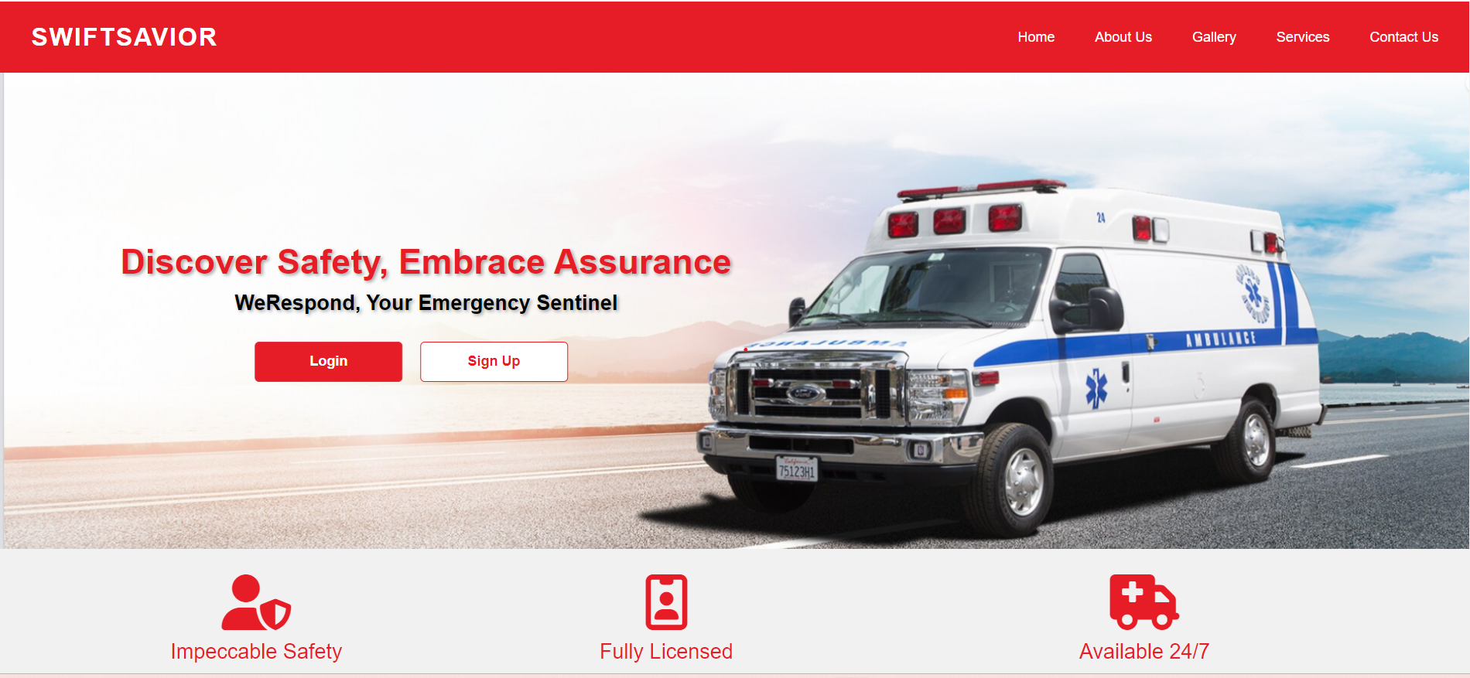

**Appendix A Home Page**

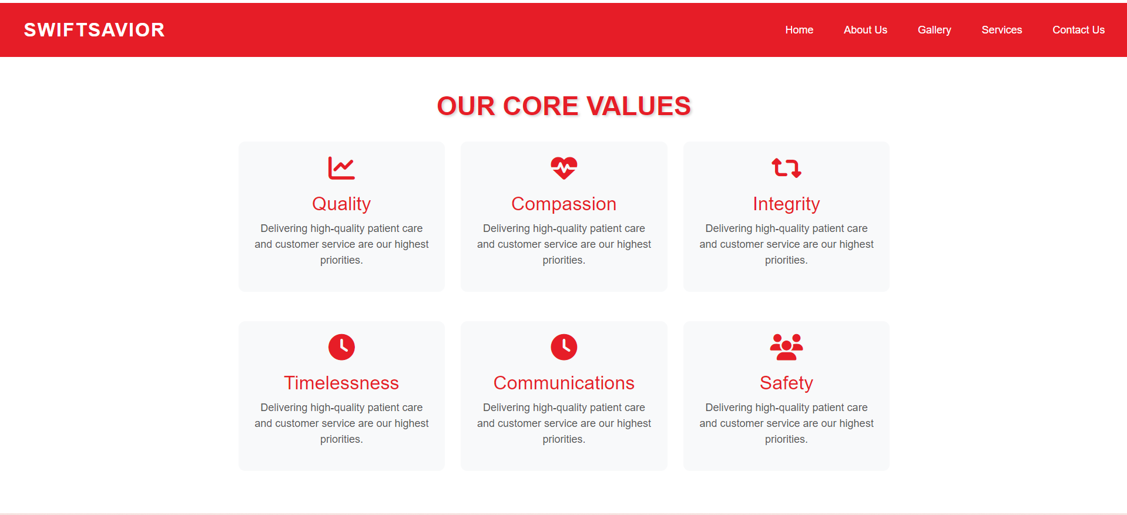

**Appendix B About Us Page**

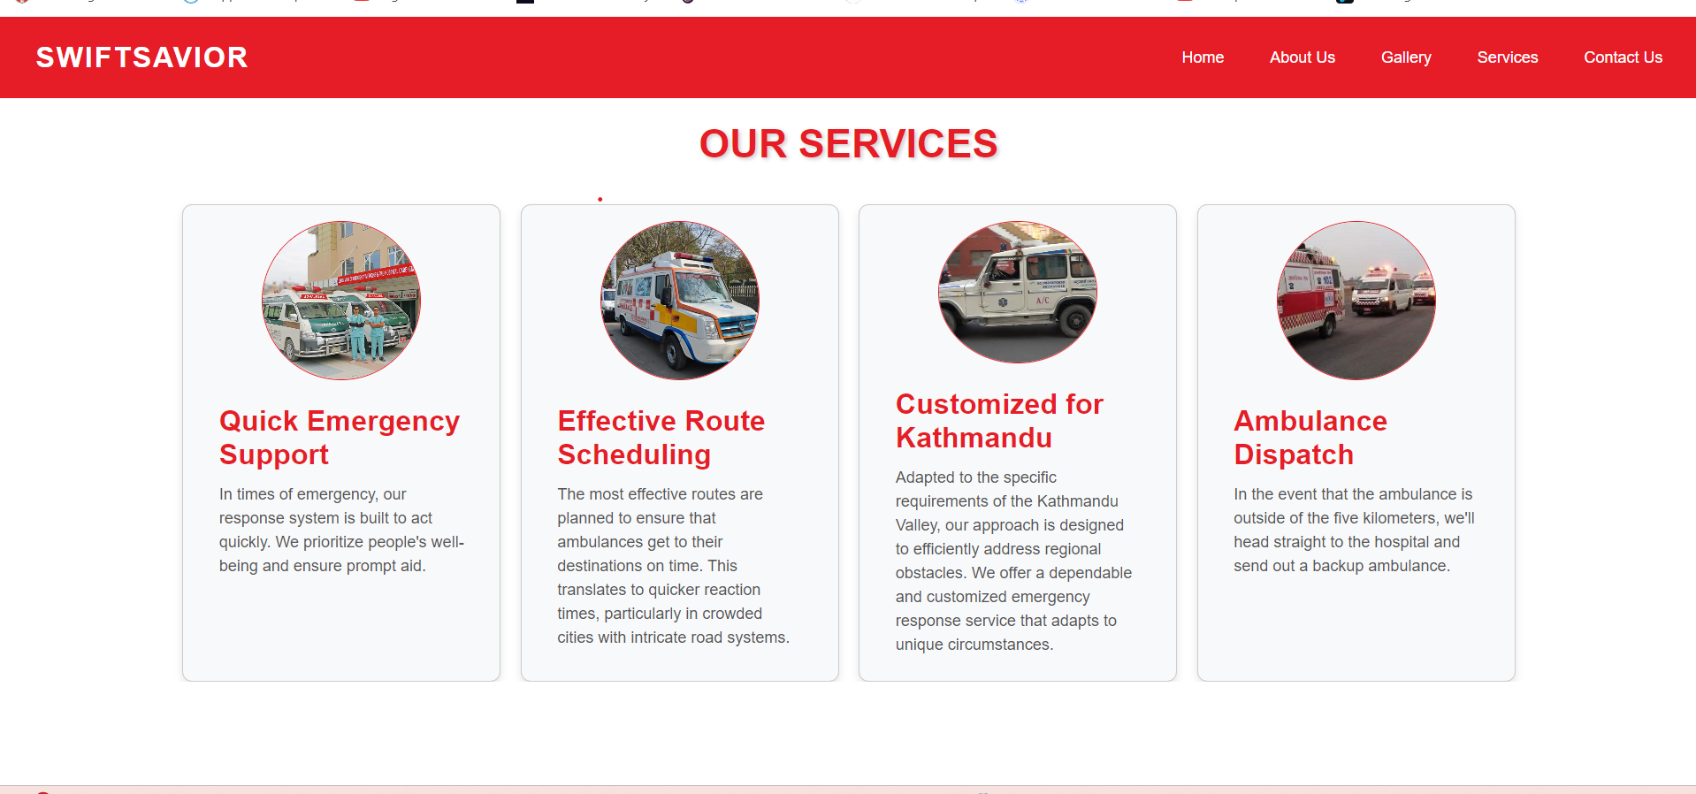

**Appendix C Services Page**

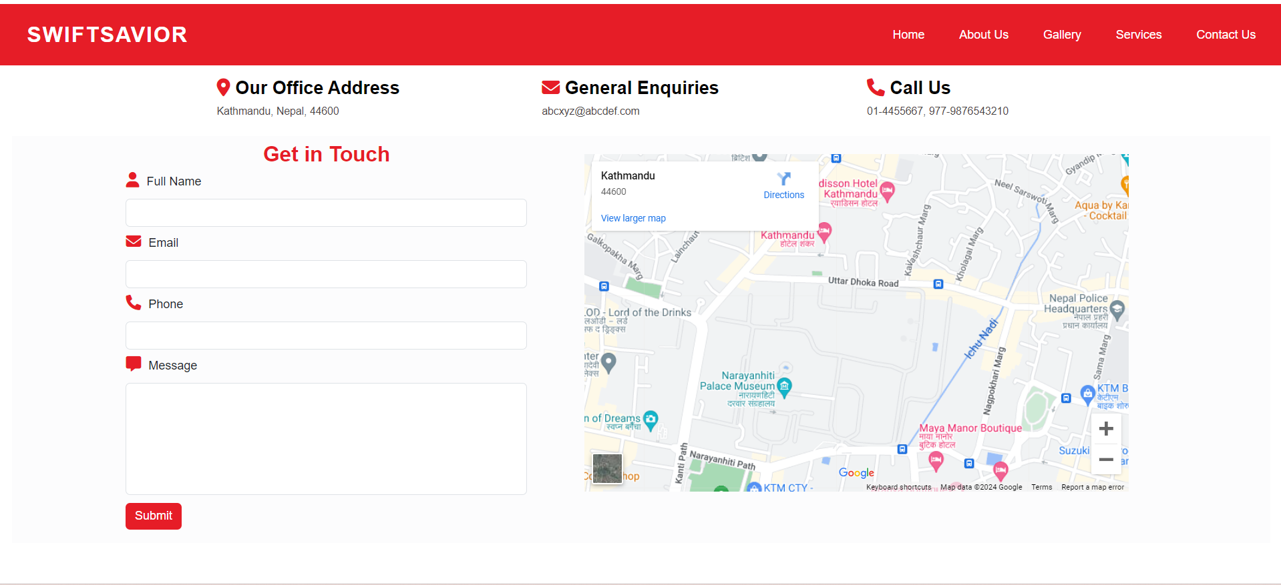

**Appendix D Contact Us Page**

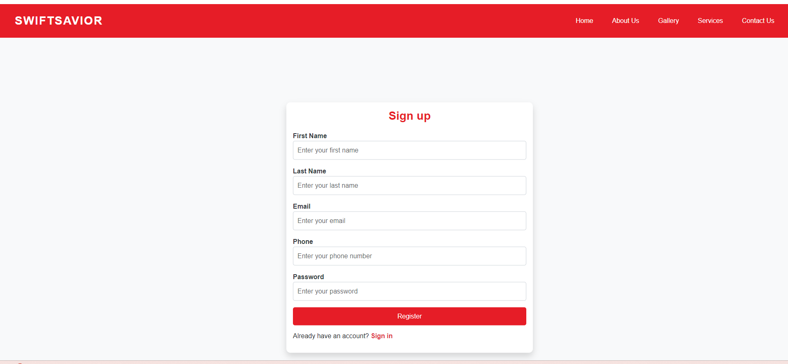

**Appendix E Sign Up Page**

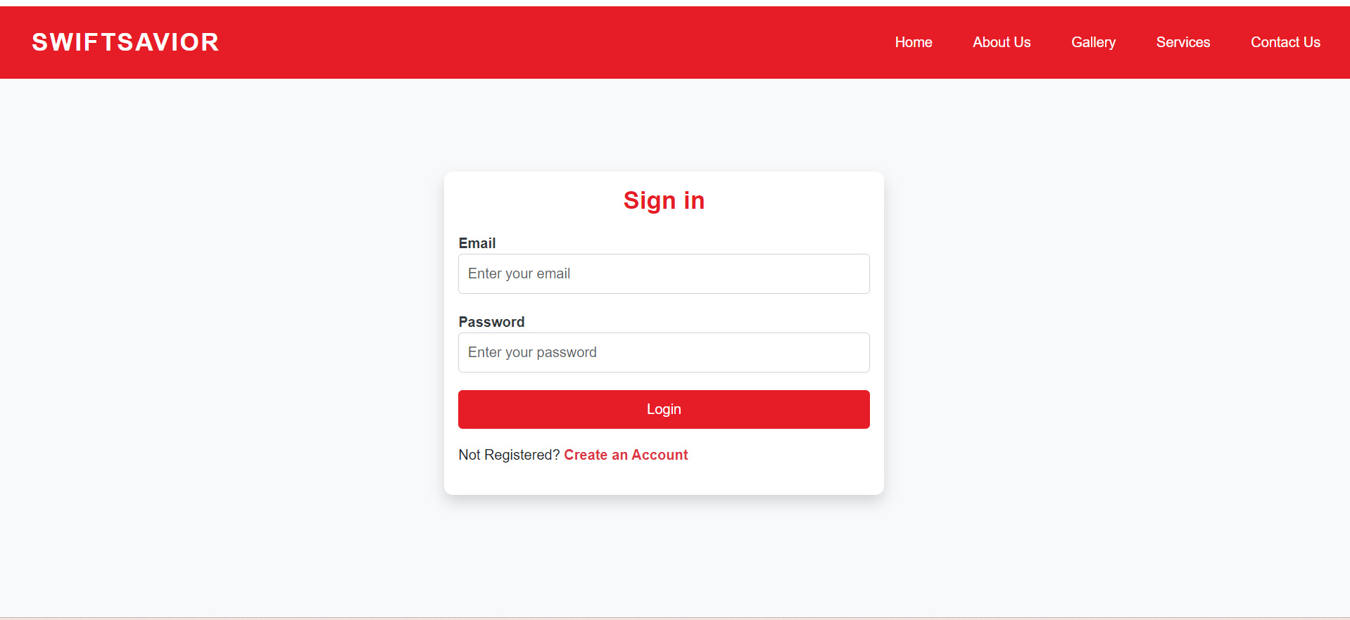

**Appendix F Sign in Page**

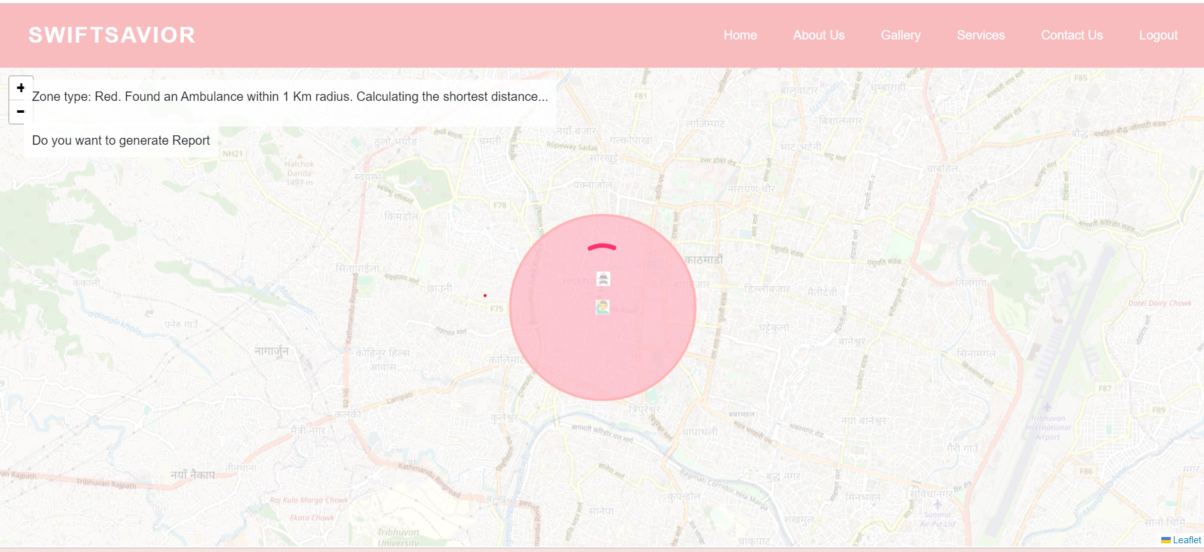

**Appendix G Nearest Ambulance Allocation**

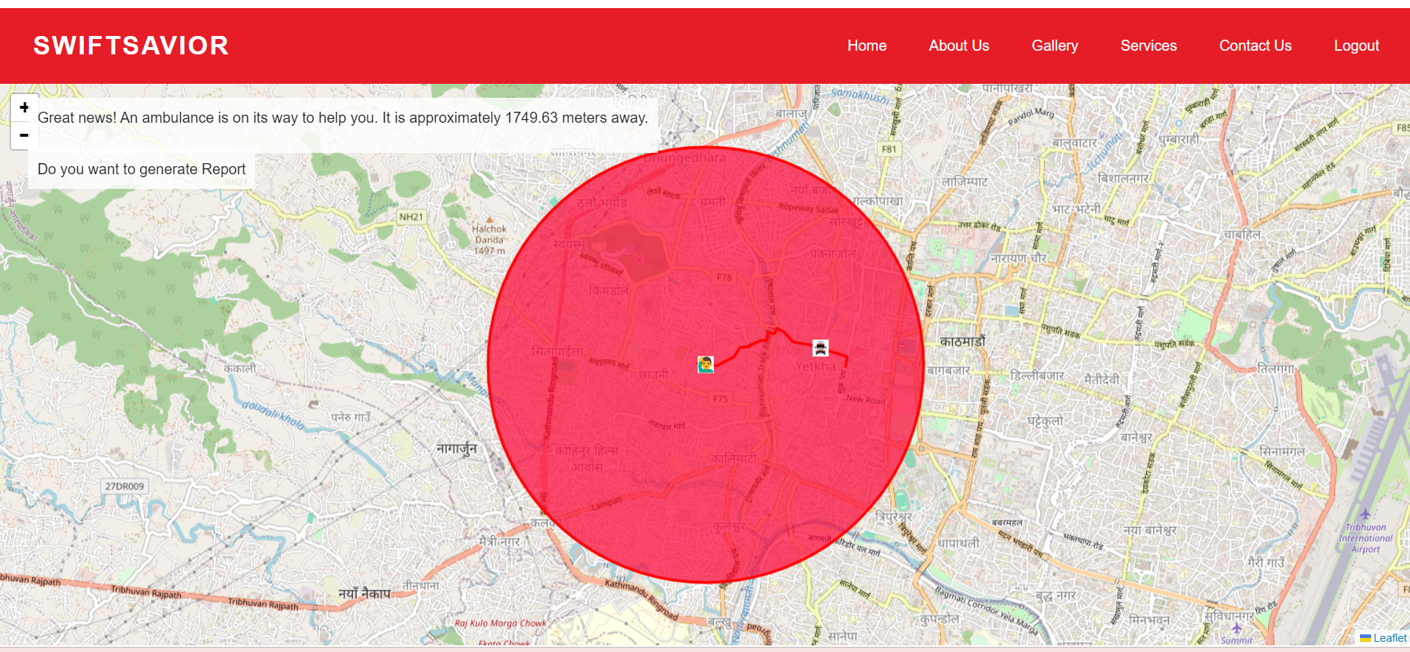

**Appendix H Shortest Path Calculation And display on Map**

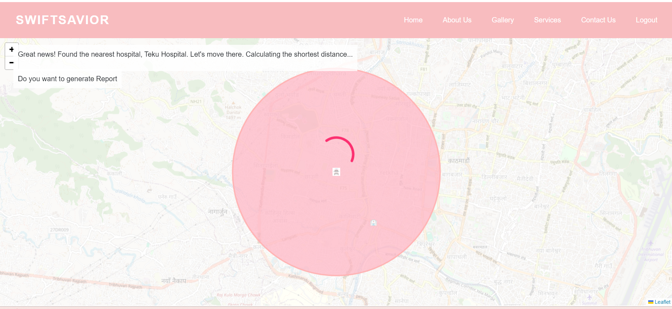

**Appendix I Nearest Hospital Allocation**

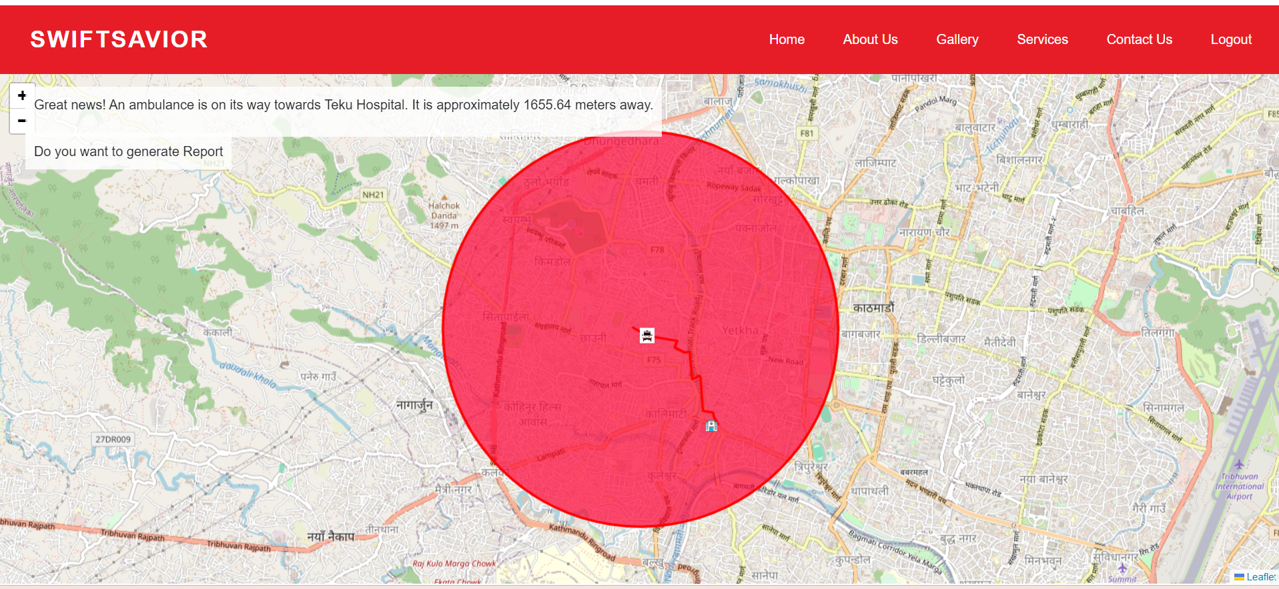

**Appendix J Calculate Shortest Path and Display on Map**

# **Pseudocode**

**map.js**

# Define DOM elements  
loaderOverlay = document.getElementById('loader-overlay')  
loader = document.getElementById('loader')  
messageContainer = document.getElementById('message-container')  
reportLink = document.getElementById('report-link')  
reportContainerForm = document.getElementById('report-form-container')

# Define event listener for report link click  
reportLink.addEventListener("click", e => {  
    e.preventDefault()  
    Toggle visibility of report form  
})

# Define function to generate report  
generateReport():  
    Get user input  
    Validate input  
    Send data to backend for PDF generation  
    Create download link for generated PDF

# Define functions for map setup and markers placement  
placeIcon(path)  
setupMap(centerLatLng, zoomLevel)  
placeMarker(map, latLng, icon, popupContent)  
placeAmbulances(map, ambulanceData)  
placeHospital(map, hospitalData)  
placeEmergencyCircle(map, centerLatLng, radius, color)  
renderShortestPath(map, shortestPathCoordinates)  
handleErrorMessage(message)

# Define async functions to fetch event data and zone type  
getEvent()  
getZoneType(eventLatitude, eventLongitude)

# Define main async function to initialize map  
async initMap():  
    Fetch random event and zone type  
    Initialize map and place event marker  
    Fetch ambulance data and radius  
    Place emergency circle on map  
    If ambulance available:  
        Show loading messages and calculate shortest path to event  
        Fetch shortest path data and render polyline  
        Animate ambulance marker along shortest path  
        Remove event and ambulance markers from map  
    Else:  
        Display message when no ambulance found  
    Create updated ambulance data array and place marker  
    Fetch hospital data and calculate shortest path to hospital  
    If hospital found:  
        Fetch shortest path data to hospital  
        Render polyline and animate ambulance marker to hospital  
        Remove polyline after animation  
    Else:  
        Handle case where no hospital is found

# Define animation function to animate ambulance marker  
async animateAmbulance(map, marker, pathCoordinates)

# Call initMap function  
initMap()

**main.py**

# Define Flask app and configuration  
Initialize Flask app with secret key and database configuration

# Define User model  
Define User model with necessary fields

# Define functions for route endpoints  
Define functions for login, registration, logout, and other routes

# Define utility functions  
Define utility functions for haversine distance calculation, zone classification, ambulance data retrieval, shortest path calculation, hospital data retrieval, and PDF generation

# Define route endpoints  
Define route endpoints for login, registration, logout, map, about us, gallery, services, contact us, and home

# Start Flask app  
Run Flask app

**shortest_path_finder.py (Dijkstra’s Algorithm Implementation)**

# Import necessary libraries  
Import osmnx as ox  
Import networkx as nx  
From geopy.distance import geodesic  
Import heapq

# Define ShortestPathFinder class  
Class ShortestPathFinder:  
    # Initialize class with graph of specified location  
    Define __init__ method:  
        Fetch and process graph for specified location  
      
    # Method to find shortest path using Dijkstra's algorithm  
    Define dijkstra method:  
        Initialize distances and predecessors dictionaries  
        Initialize priority queue with start node  
        While priority queue is not empty:  
            Pop node with smallest distance from priority queue  
            If current node is end node, return shortest path and distance  
            For each neighbor of current node:  
                Calculate distance between nodes using geodesic distance  
                Update distance and predecessors if shorter path is found  
                Push neighbor to priority queue  
              
    # Method to find shortest path between two points  
    Define find_shortest_path method:  
        Convert start and end points to nearest graph nodes  
        Call dijkstra method to find shortest path and distance  
          
    # Method to extract coordinates from node list  
    Define get_coordinates method:  
        Return coordinates of nodes in list